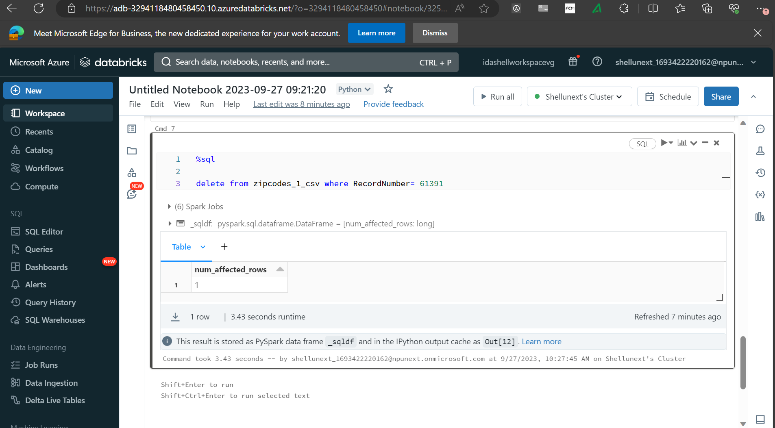

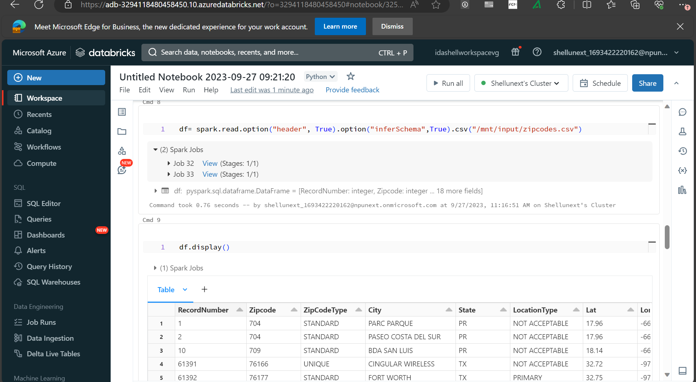

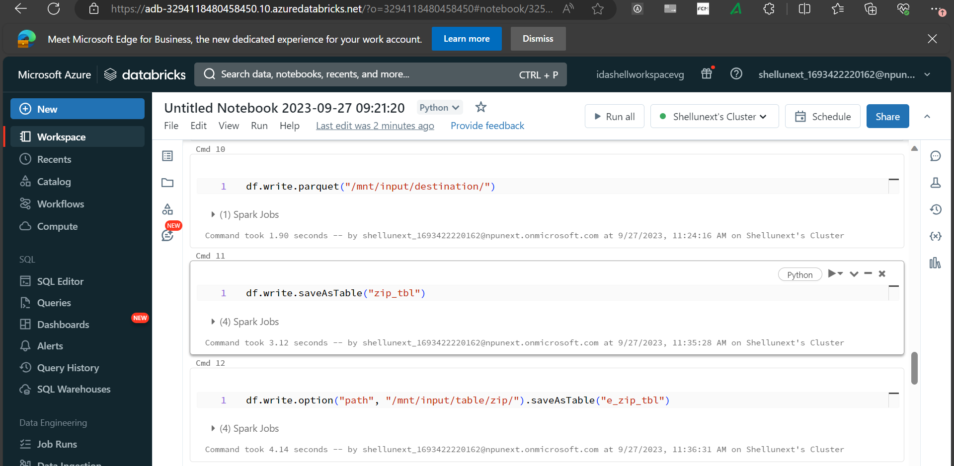

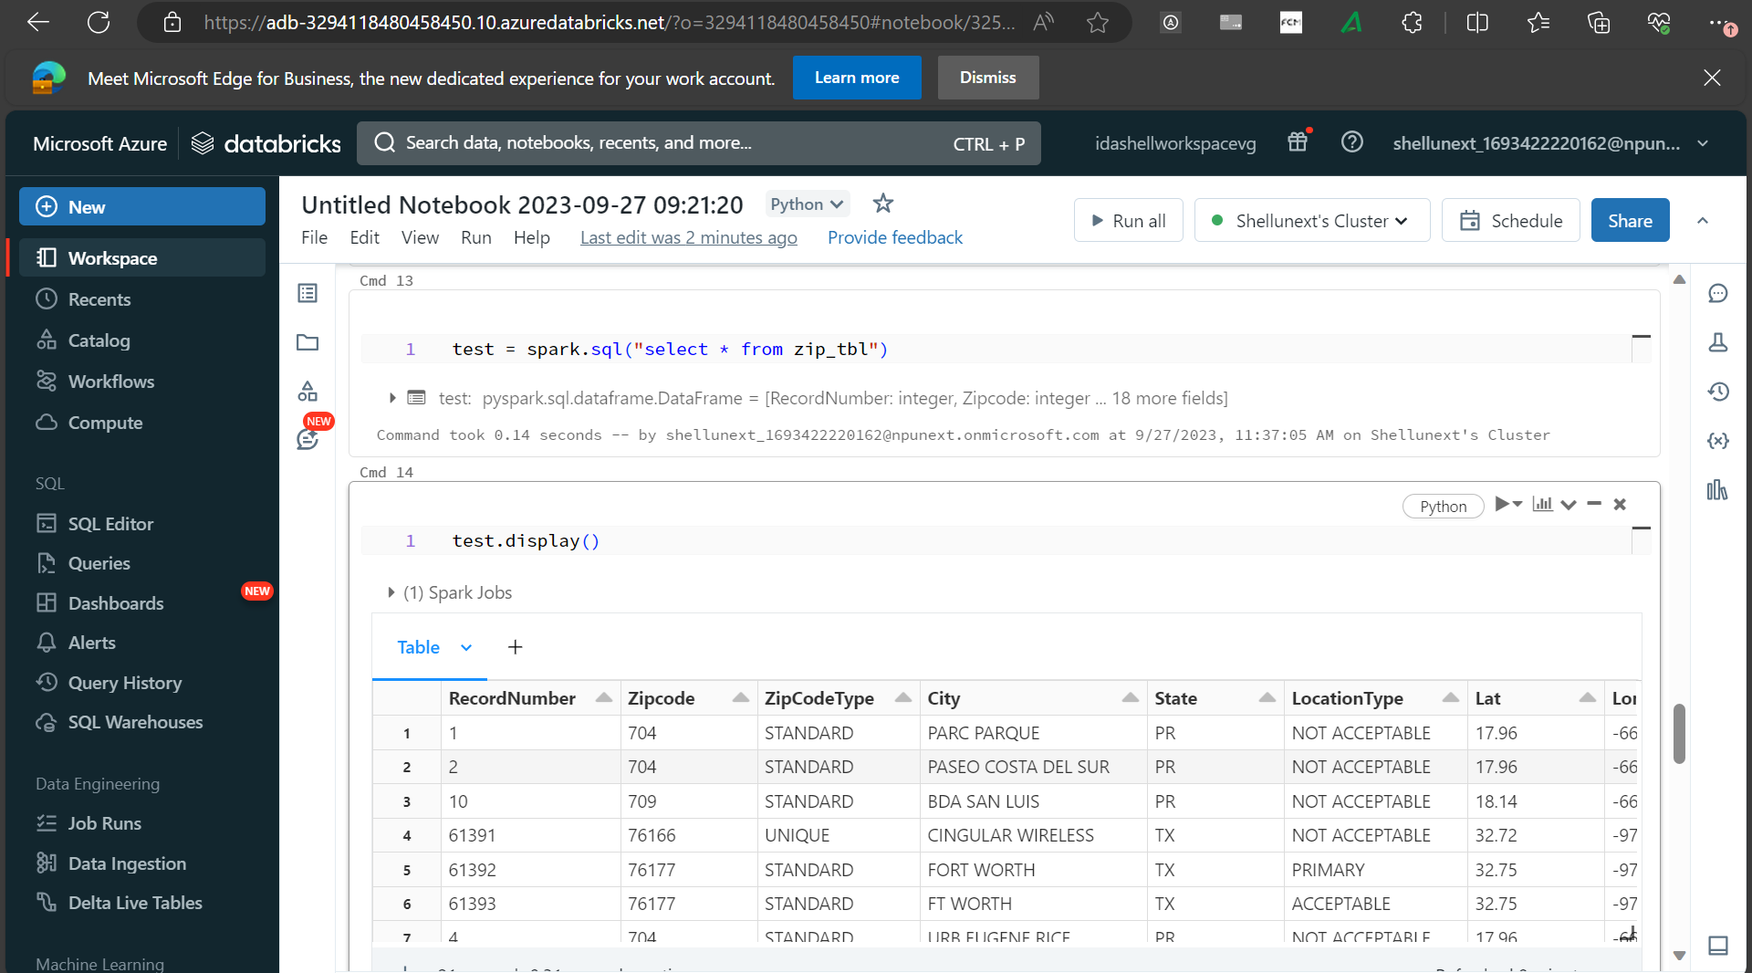

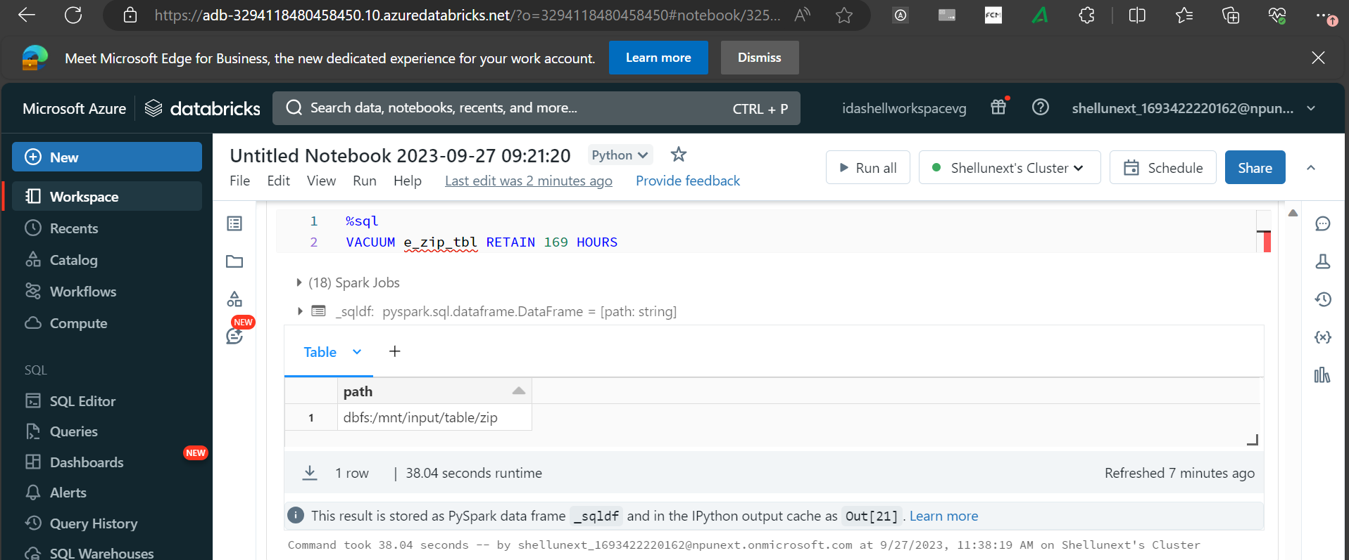

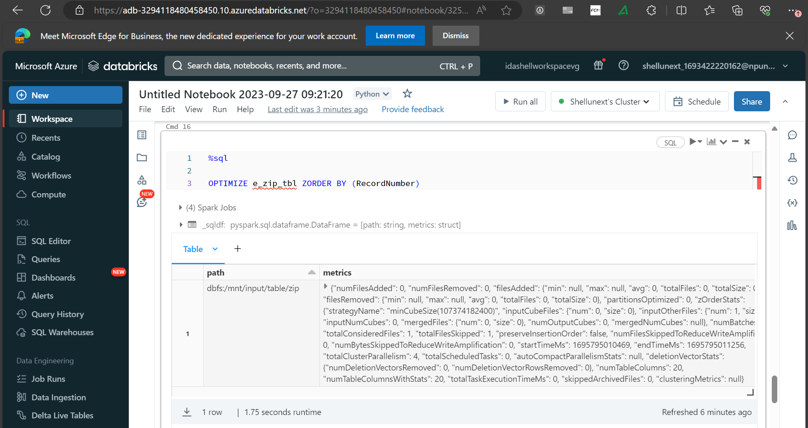

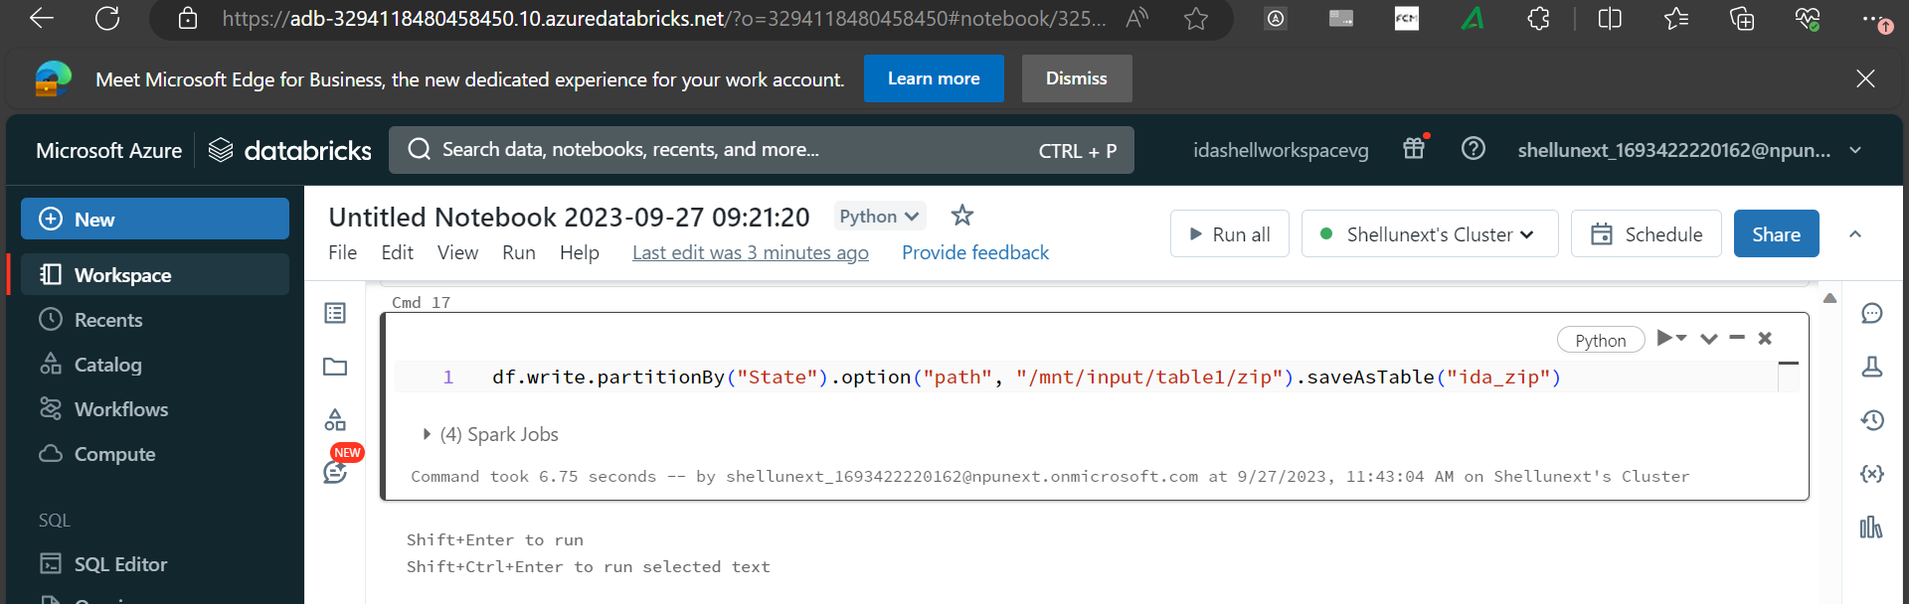

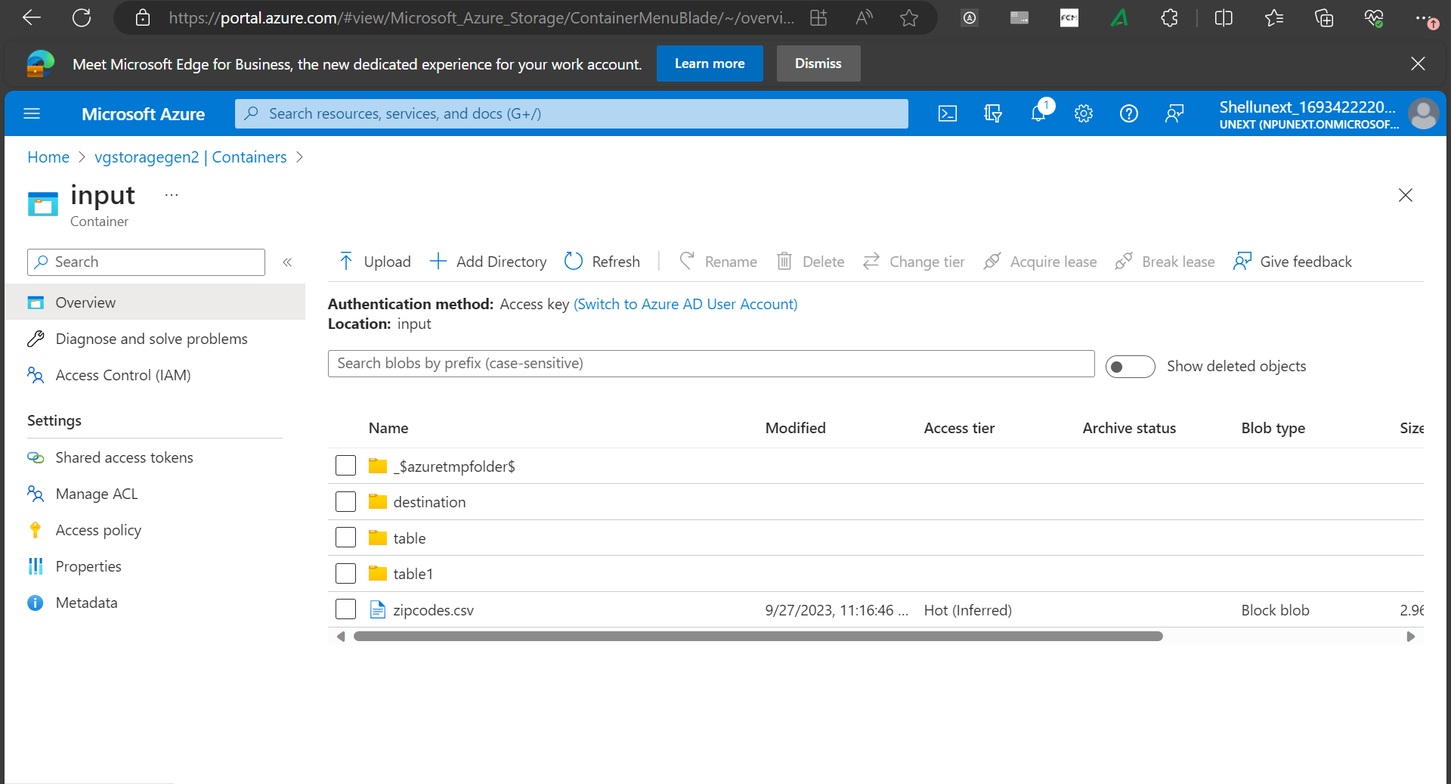

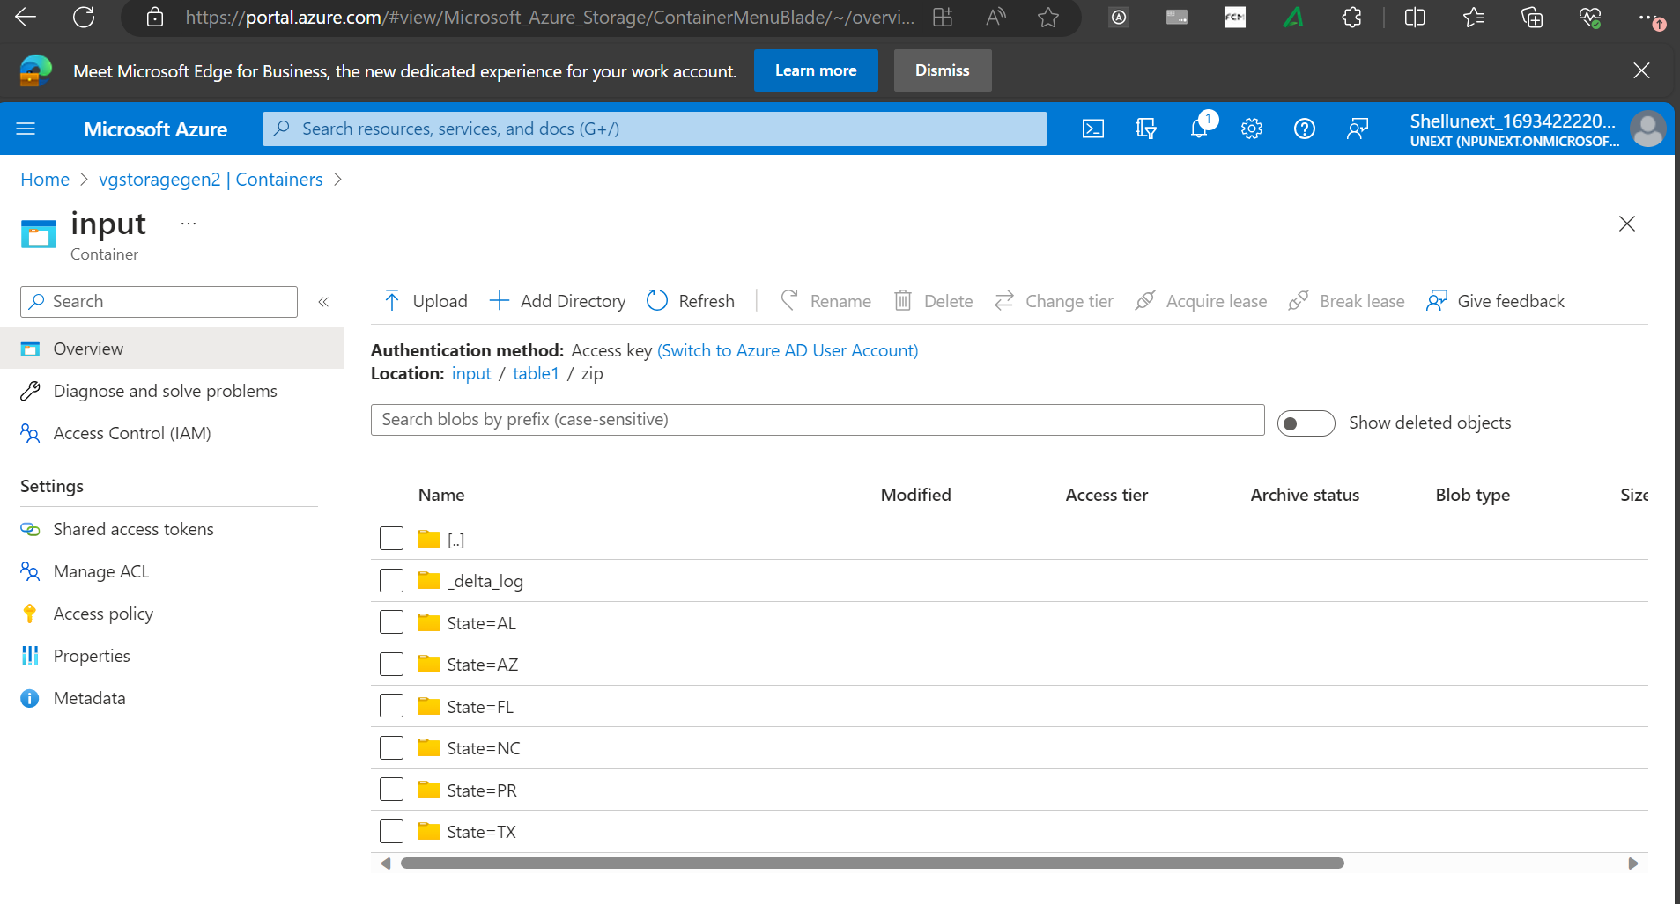

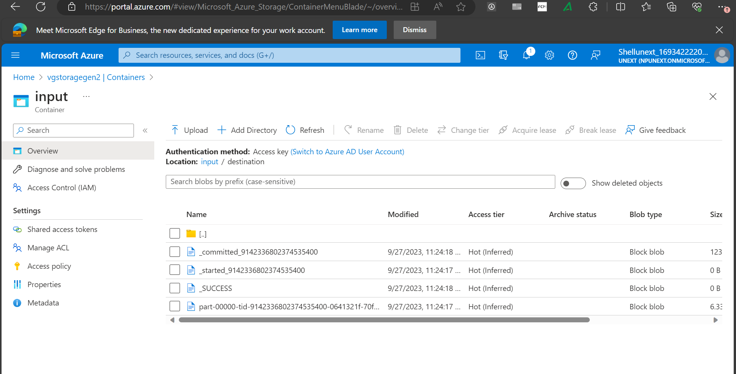

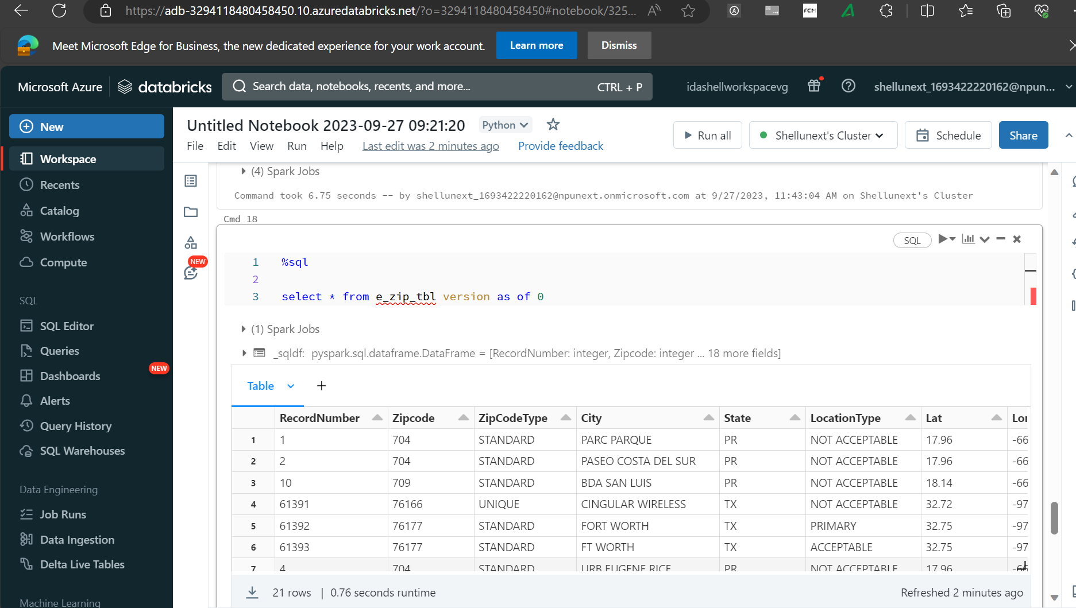

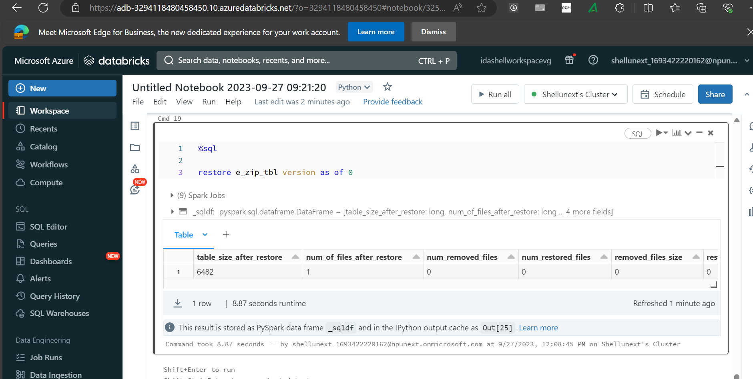

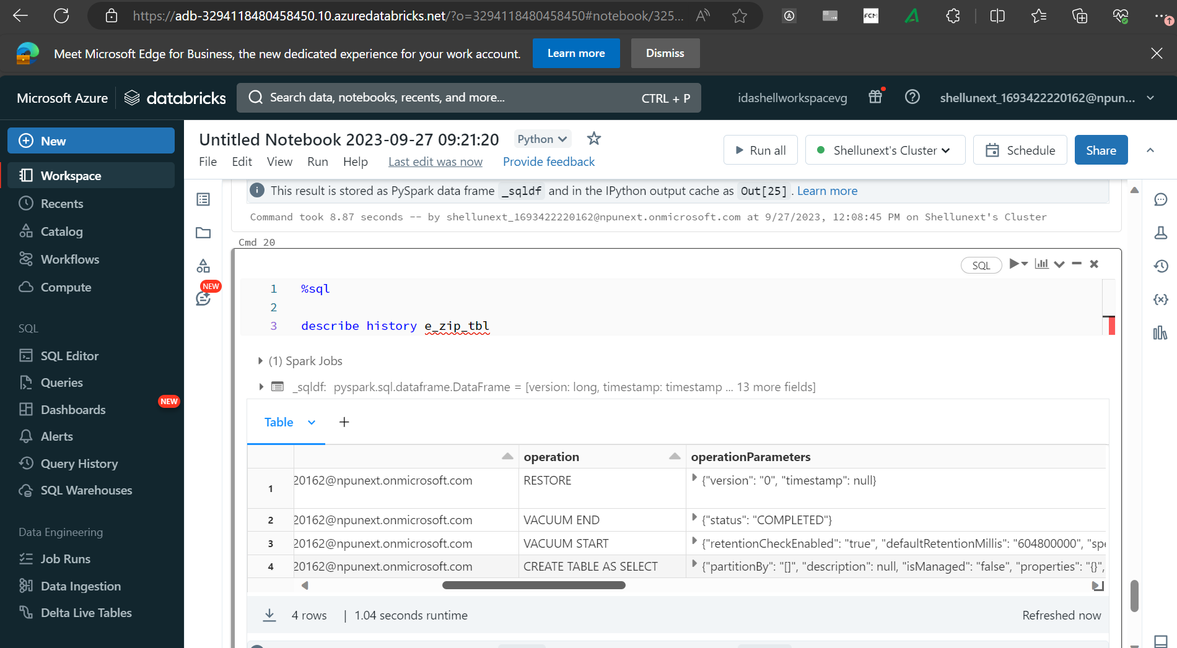

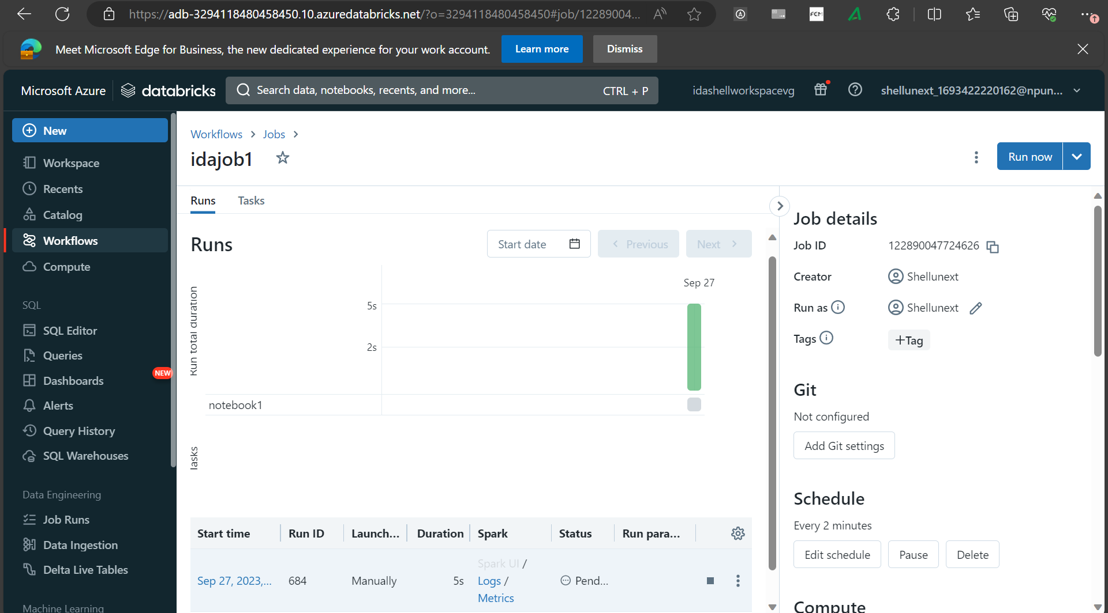

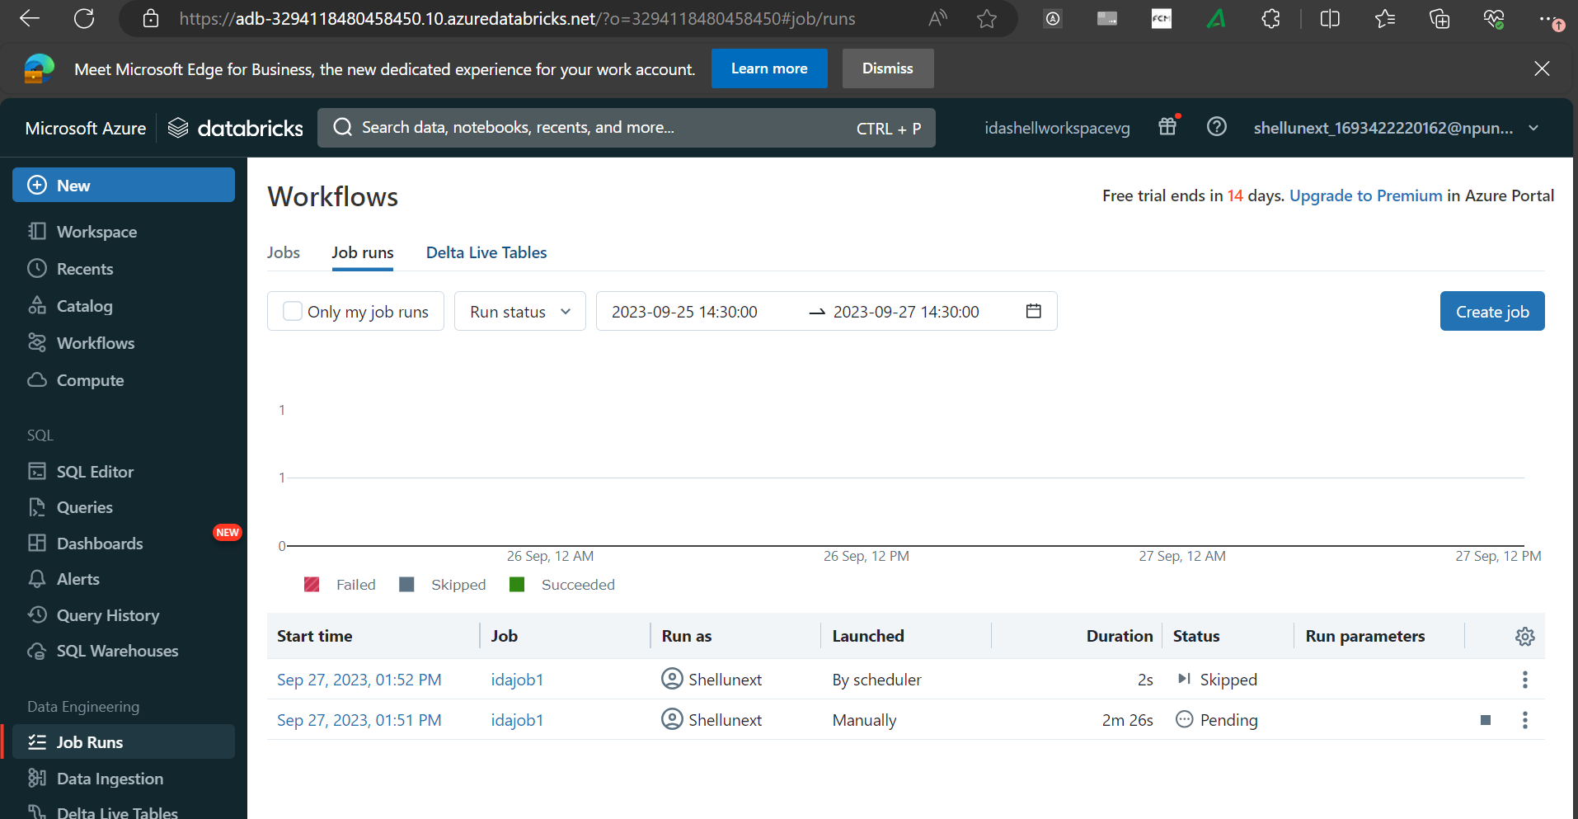

28/9/23

app.py

from flask import Flask

app = Flask(__name__)

@app.route('/')

def hello():

return "Hello, Azure Container!"

++++++++++++++++++++++++++++++++++++++++++++++++++

requiremnet.txt

Flask==2.0.1

++++++++++++++++++++++++++++++++++++++++++++++++++

Dockerfile

# Use an official Python runtime as a parent image

FROM python:3.8-slim-buster

# Set the working directory to /app

WORKDIR /app

# Copy the current directory contents into the container at /app

COPY . /app

# Install any needed packages specified in requirements.txt

RUN pip install -r requirements.txt

# Make port 80 available to the world outside this container

EXPOSE 80

# Define environment variable

ENV NAME World

# Run app.py when the container launches

CMD ["python", "app.py"]

===================================

dbutils.widgets.text("test","")

a = dbutils.widgets.get("ida")

print(a)

dbutils.widgets.dropdown("choose_colors","white",["Red","Black","Blue","white"],"color dropdwon")

t = dbutils.widgets.get("choose_colors")

print(t)

dbutils.widgets.combobox("combo_ida","test",["1","2","3"])

bmghNcbolaW1EOx7MI5MNor7XG7Zs0Eb2hE4azGotWam3hIbGJxVtioqDUlSU1tuz1YhKVswwkOd+AStKlXIwQ==

************

dbutils.fs.mount(source = "wasbs://input@idashelladlsgen2.blob.core.windows.net",

mount_point ="/mnt/input",

extra_configs = {"fs.azure.account.key.idashelladlsgen2.blob.core.windows.net":dbutils.secrets.get(scope = "adbScope", key = "adlsgen2")})

**********************************

widget use case

import time

input_value = dbutils.widgets.get("ida")

operation_type = dbutils.widgets.get("ida1")

# Define a function to perform the specified operation

def perform_operation(value, operation):

if operation == "Double":

return value * 2

elif operation == "Square":

return value ** 2

else:

return "Invalid operation"

# Process the user input

try:

input_value = float(input_value)

result = perform_operation(input_value, operation_type)

print(f"Result of {operation_type} operation on {input_value}: {result}")

except ValueError:

print("Invalid input. Please enter a numeric value.")

# Sleep for a while to keep the notebook running

time.sleep(5)

***************************

Structured Streaming

**

from pyspark.sql.types import *

schema = StructType([StructField("lsoa_code", StringType(), True),\

StructField("borough", StringType(), True),\

StructField("major_category", StringType(), True),\

StructField("minor_category", StringType(), True),\

StructField("value", StringType(), True),\

StructField("year", StringType(), True),\

StructField("month", StringType(), True)])

Streamdf = spark.readStream.schema(schema).option("header",True).csv("/mnt/input/droplocation")

trimmedDF = Streamdf.select(

Streamdf.borough,

Streamdf.year,

Streamdf.month,

Streamdf.value

)\

.withColumnRenamed(

"value",

"convictions"

)

query = trimmedDF.writeStream\

.outputMode("append")\

.format("csv") \

.option("path", "/mnt/input/destination") \

.option("checkpointLocation", "/mnt/input/checkpoint") \

.start()\

.awaitTermination()

Link for dataset : https://github.com/harunraseed/Stream_Dataset.git

<https://medium.com/@harun.raseed093/unity-catalog-in-databricks-54bab3afbb35>

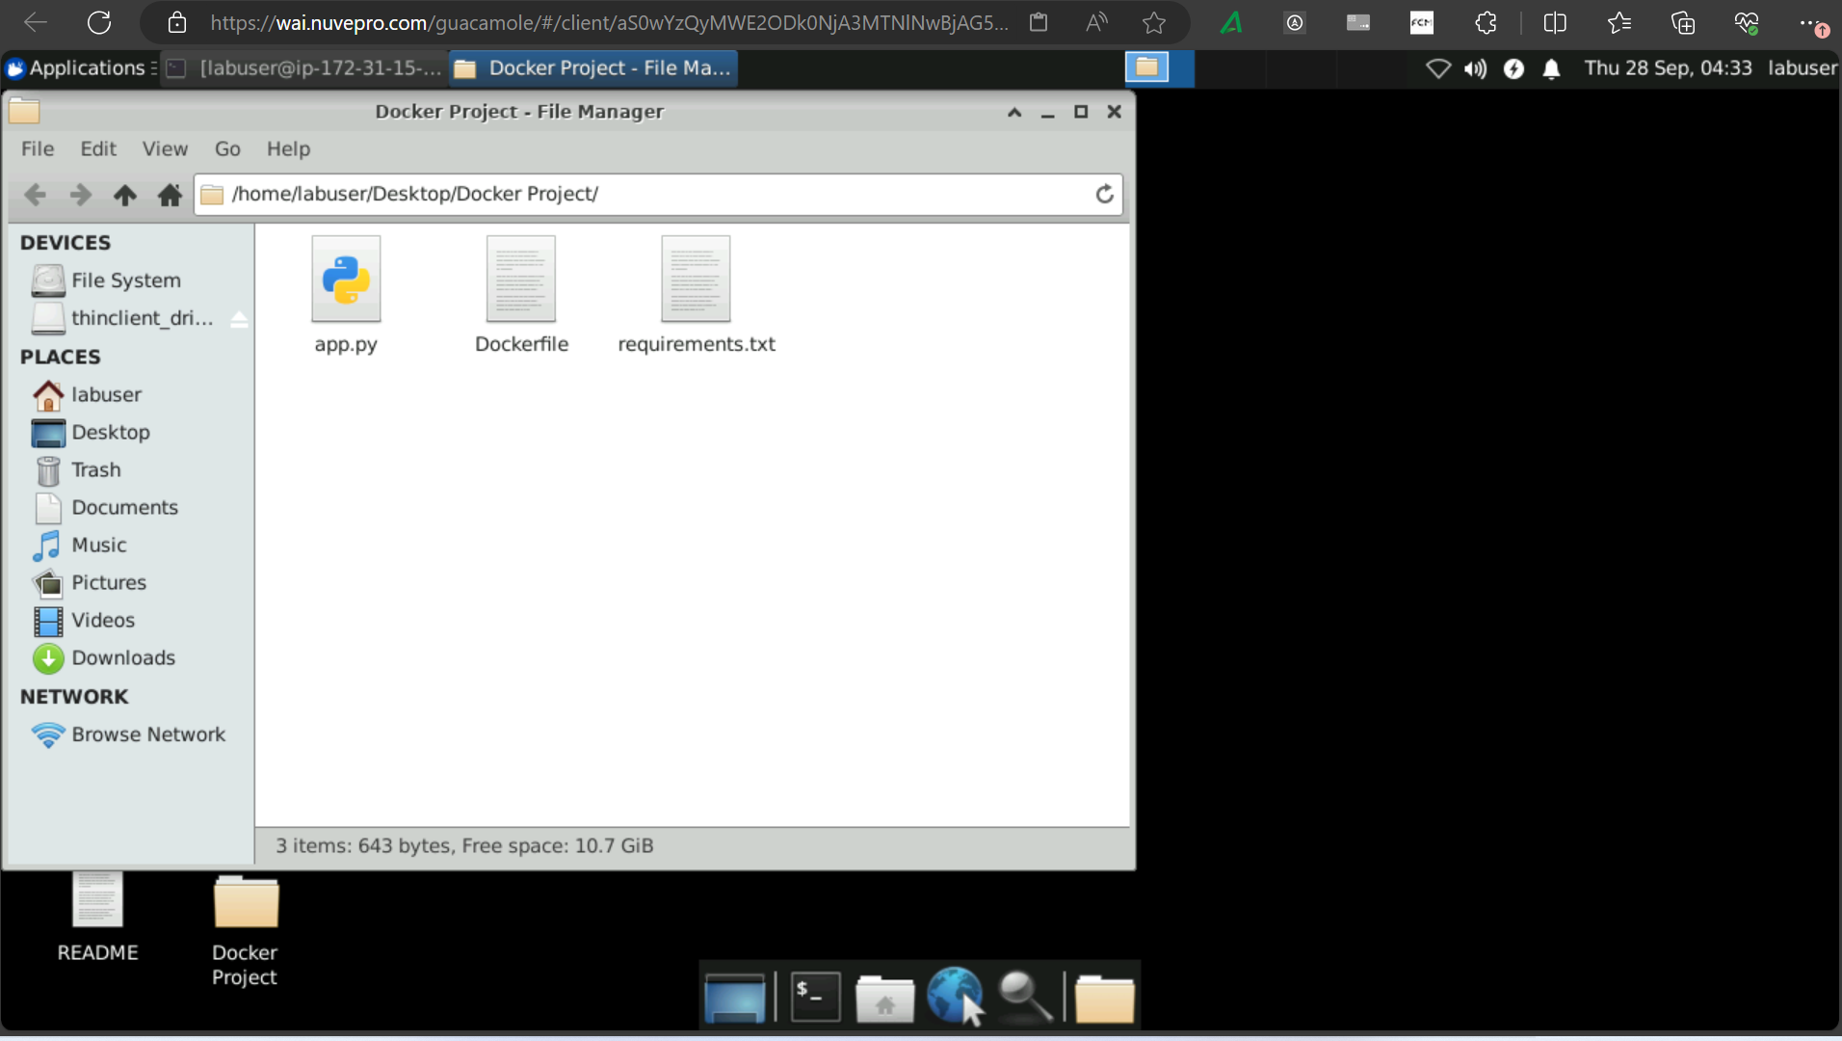

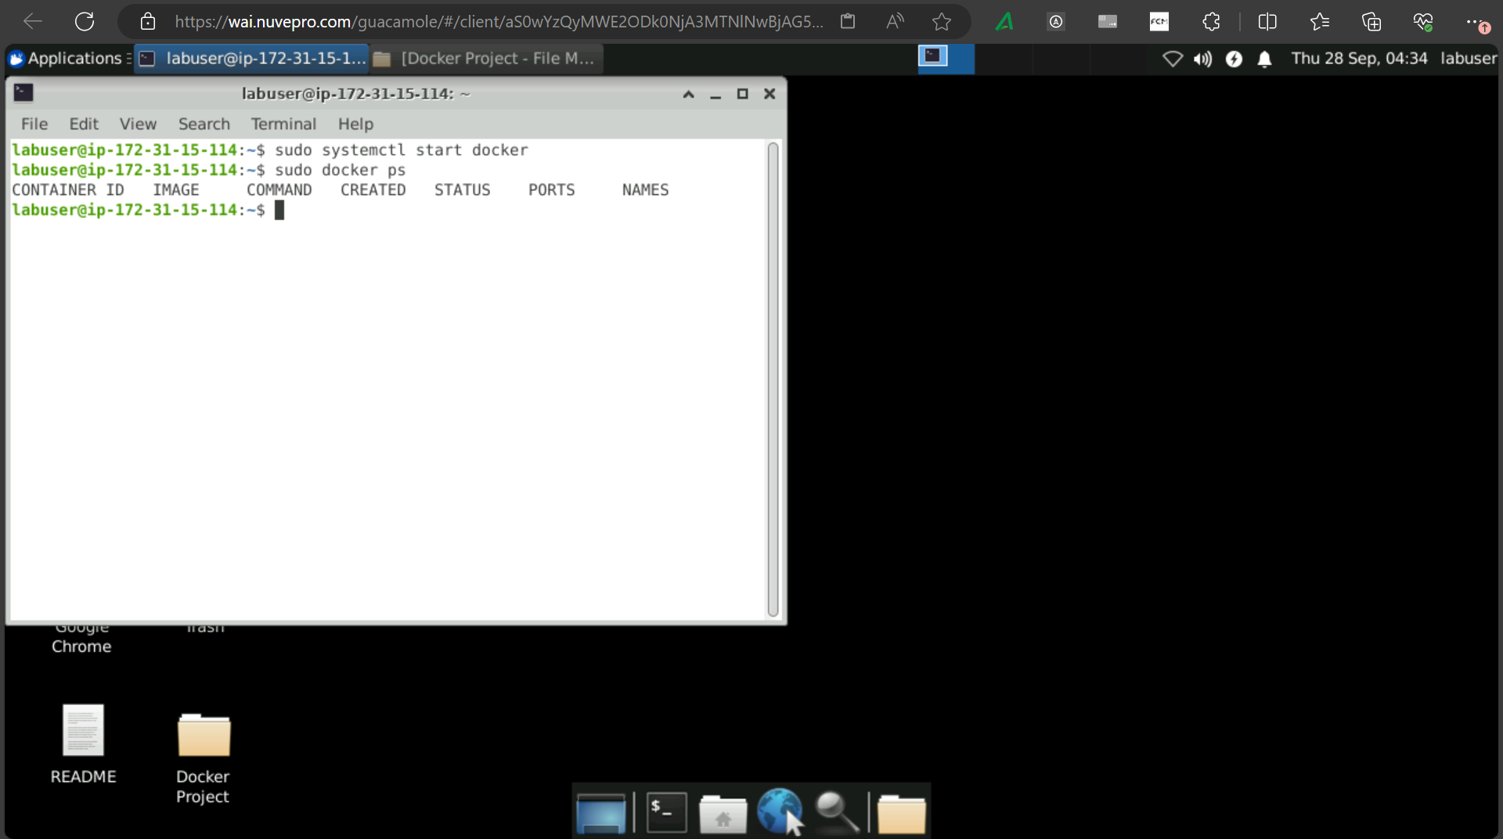

app.py

from flask import Flask

app = Flask(__name__)

@app.route('/')

def index():

return 'Web App with Python Flask!'

app.run(host='0.0.0.0', port=81)

++++++++++++++++++++++++++++++++++++++++++++++++++

requiremnet.txt

Flask==2.0.1

++++++++++++++++++++++++++++++++++++++++++++++++++

Dockerfile

# Use an official Python runtime as a parent image

FROM python:3.8-slim-buster

# Set the working directory to /app

WORKDIR /app

# Copy the current directory contents into the container at /app

COPY . /app

# Install any needed packages specified in requirements.txt

RUN pip install -r requirements.txt

# Make port 80 available to the world outside this container

EXPOSE 80

# Define environment variable

ENV NAME World

# Run app.py when the container launches

CMD ["python", "app.py"]

+++++++++++++++++++++++++++++++++++

sudo systemctl start docker

===================================

dbutils.widgets.text("test","")

a = dbutils.widgets.get("ida")

print(a)

dbutils.widgets.dropdown("choose_colors","white",["Red","Black","Blue","white"],"color dropdwon")

t = dbutils.widgets.get("choose_colors")

print(t)

dbutils.widgets.combobox("combo_ida","test",["1","2","3"])

bmghNcbolaW1EOx7MI5MNor7XG7Zs0Eb2hE4azGotWam3hIbGJxVtioqDUlSU1tuz1YhKVswwkOd+AStKlXIwQ==

************

dbutils.fs.mount(source = "wasbs://input@idashelladlsgen2.blob.core.windows.net",

mount_point ="/mnt/input",

extra_configs = {"fs.azure.account.key.idashelladlsgen2.blob.core.windows.net":dbutils.secrets.get(scope = "adbScope", key = "adlsgen2")})

**********************************

widget use case

import time

input_value = dbutils.widgets.get("ida")

operation_type = dbutils.widgets.get("ida1")

# Define a function to perform the specified operation

def perform_operation(value, operation):

if operation == "Double":

return value * 2

elif operation == "Square":

return value ** 2

else:

return "Invalid operation"

# Process the user input

try:

input_value = float(input_value)

result = perform_operation(input_value, operation_type)

print(f"Result of {operation_type} operation on {input_value}: {result}")

except ValueError:

print("Invalid input. Please enter a numeric value.")

# Sleep for a while to keep the notebook running

time.sleep(5)

***************************

Structured Streaming

**

from pyspark.sql.types import *

schema = StructType([StructField("lsoa_code", StringType(), True),\

StructField("borough", StringType(), True),\

StructField("major_category", StringType(), True),\

StructField("minor_category", StringType(), True),\

StructField("value", StringType(), True),\

StructField("year", StringType(), True),\

StructField("month", StringType(), True)])

Streamdf = spark.readStream.schema(schema).option("header",True).csv("/mnt/input/droplocation")

trimmedDF = Streamdf.select(

Streamdf.borough,

Streamdf.year,

Streamdf.month,

Streamdf.value

)\

.withColumnRenamed(

"value",

"convictions"

)

query = trimmedDF.writeStream\

.outputMode("append")\

.format("csv") \

.option("path", "/mnt/input/destination") \

.option("checkpointLocation", "/mnt/input/checkpoint") \

.start()\

.awaitTermination()

Link for dataset : https://github.com/harunraseed/Stream_Dataset.git

<https://medium.com/@harun.raseed093/unity-catalog-in-databricks-54bab3afbb35>

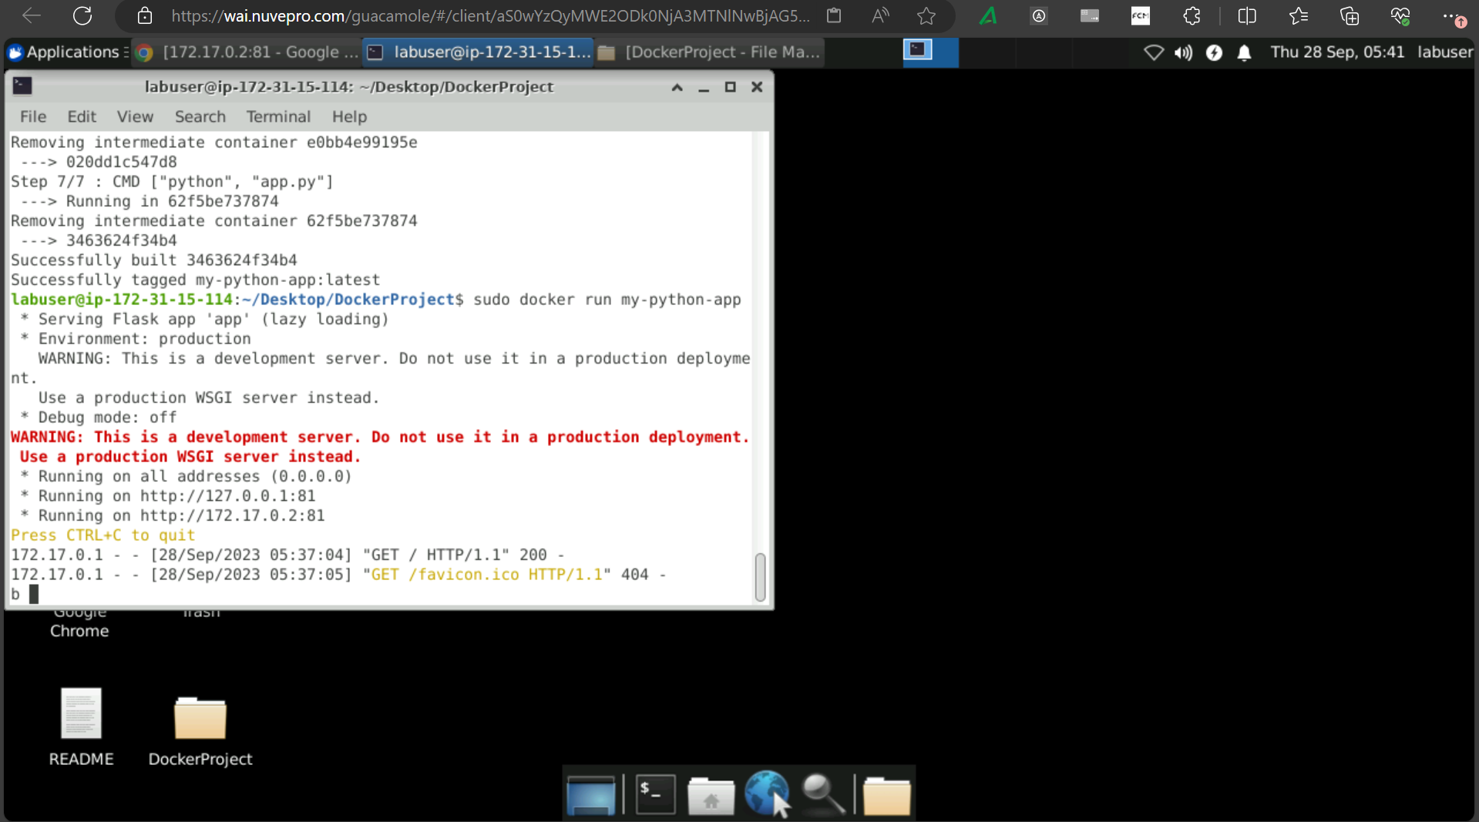

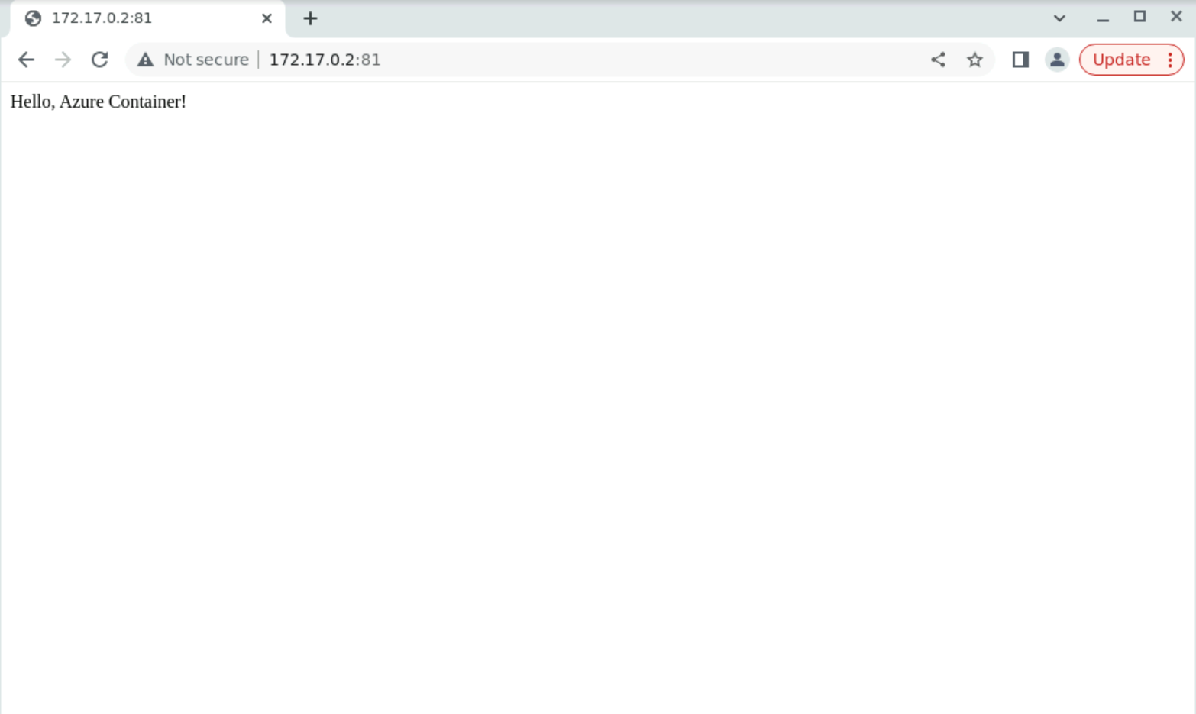

install azure cli

curl -sL https://aka.ms/InstallAzureCLIDeb | sudo bash

create resource group

az group create --name RG_shell --location eastus

____________________________________________________

az login -u Shellunext_3243423432@npunext.onmicrosoft.com -p fdffd5717454545*

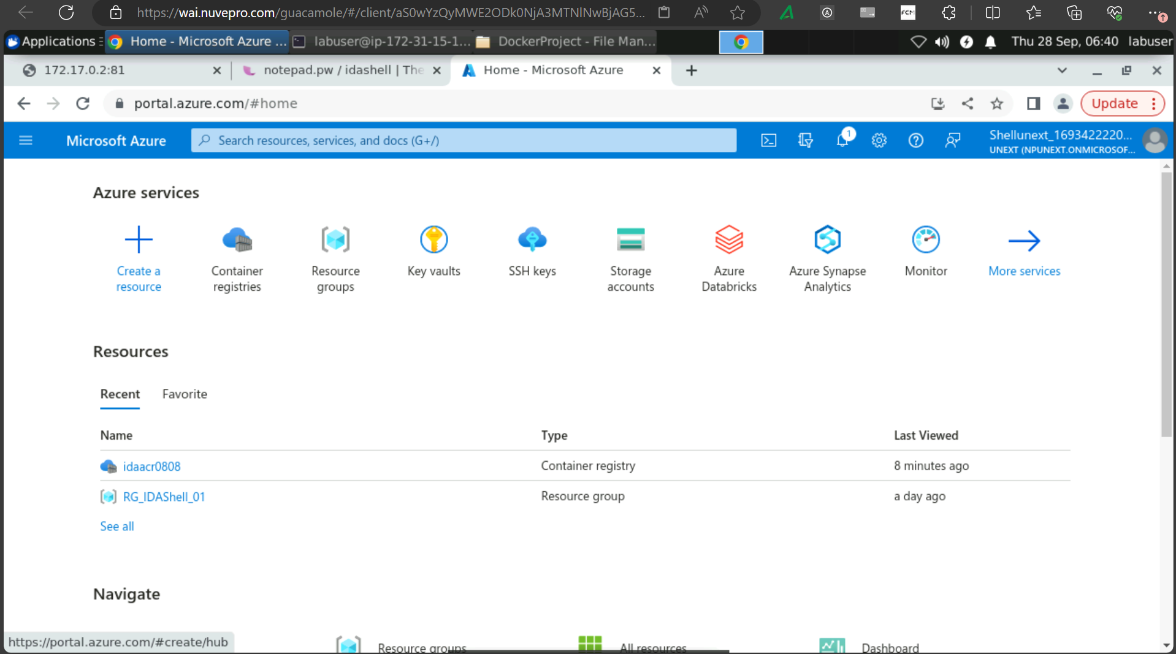

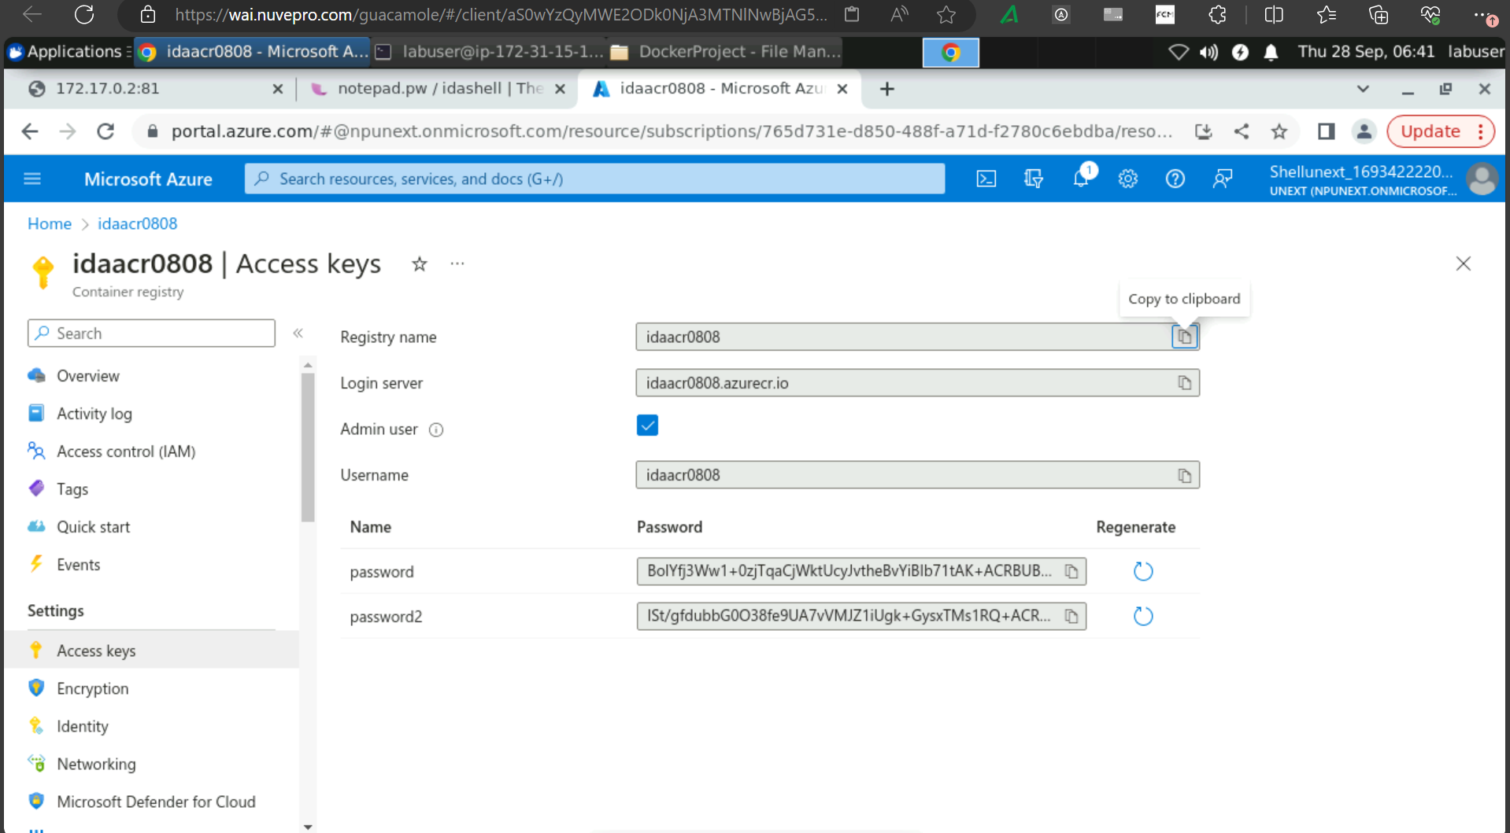

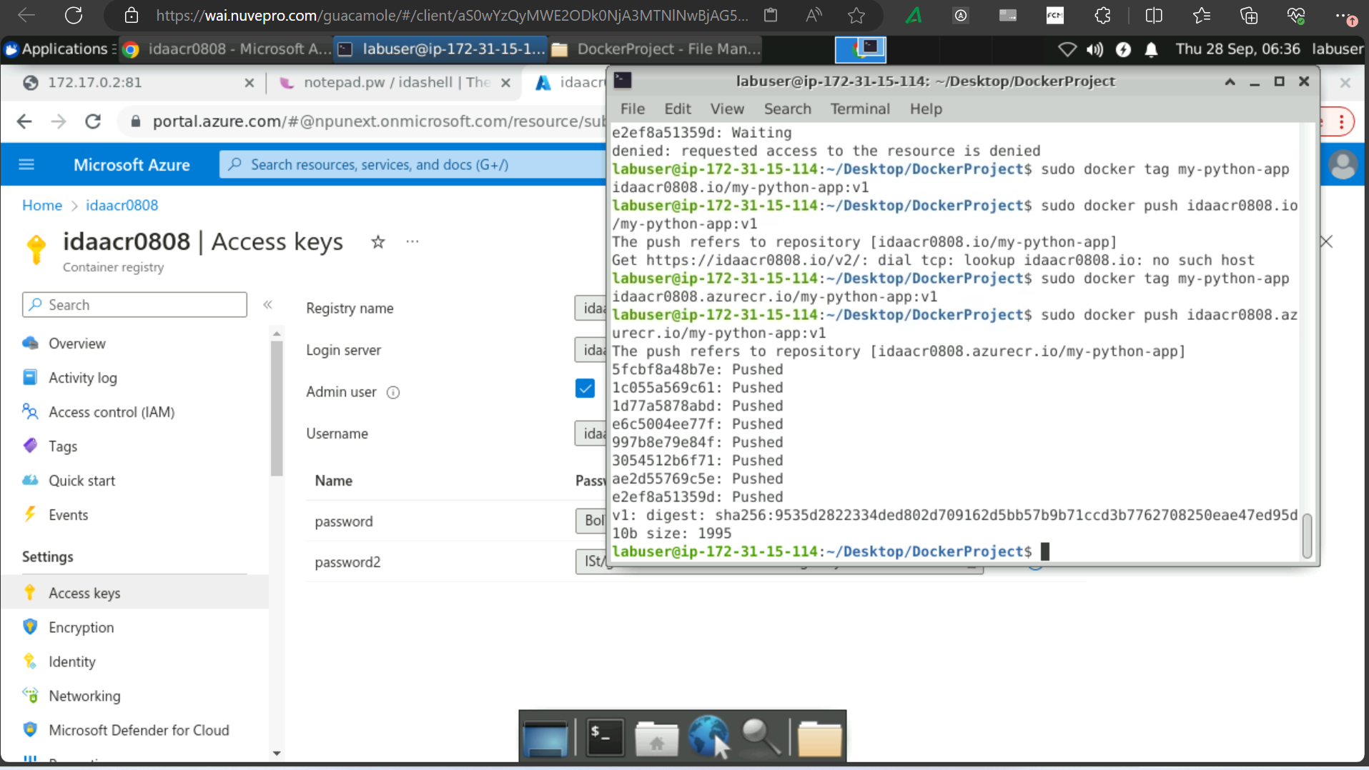

Deployment.yaml

apiVersion: apps/v1

kind: Deployment

metadata:

name: my-app

spec:

replicas: 2

selector:

matchLabels:

app: my-app

template:

metadata:

labels:

app: my-app

spec:

containers:

- name: my-app

image: idaacr0707.azurecr.io/my-python-app:v1

ports:

- containerPort: 5000

service.yaml

apiVersion: v1

kind: Service

metadata:

name: my-python-app

spec:

selector:

app: my-app

ports:

- protocol: TCP

port: 80

targetPort: 5000

type: LoadBalancer

az acr create --name <acr name> --resource-group RG_shell --location eastus --sku Standard

az aks update -n <k8s-cluster-name> -g <Resource Group name> --attach-acr <ACR name>

29/9/23

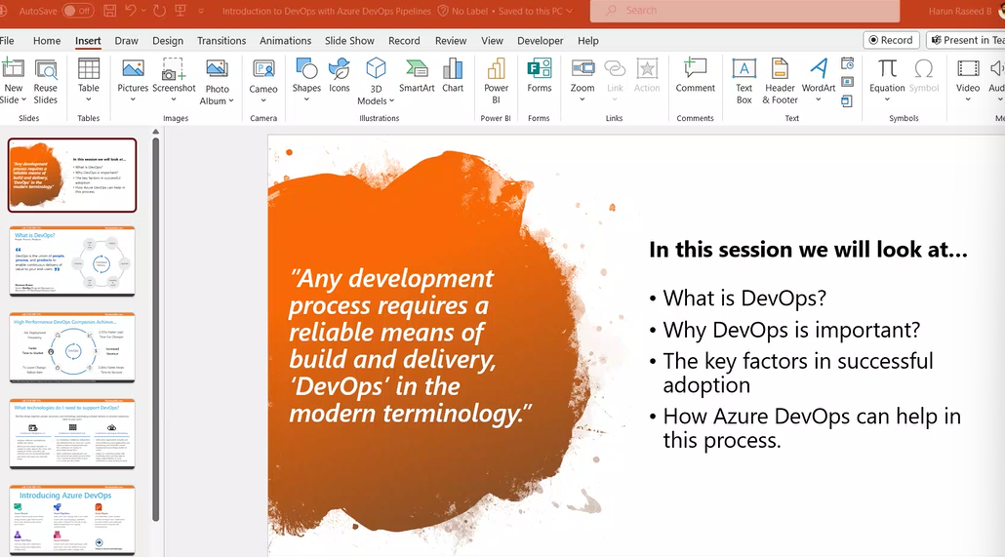

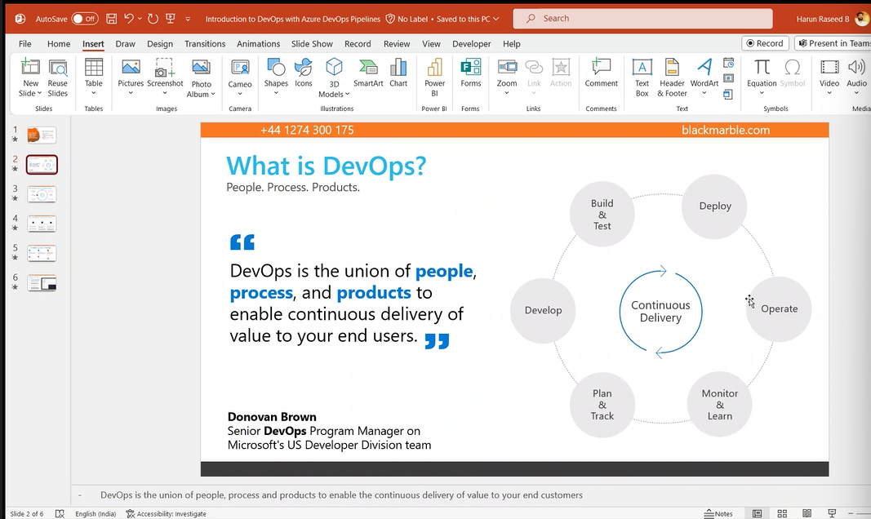

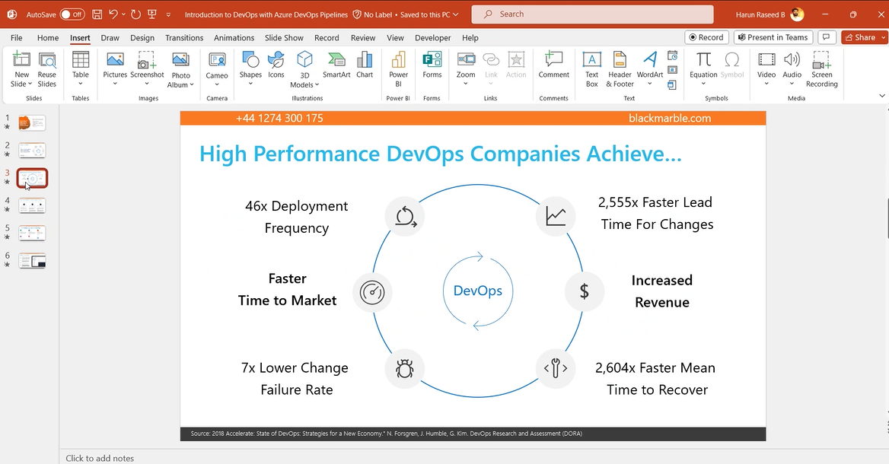

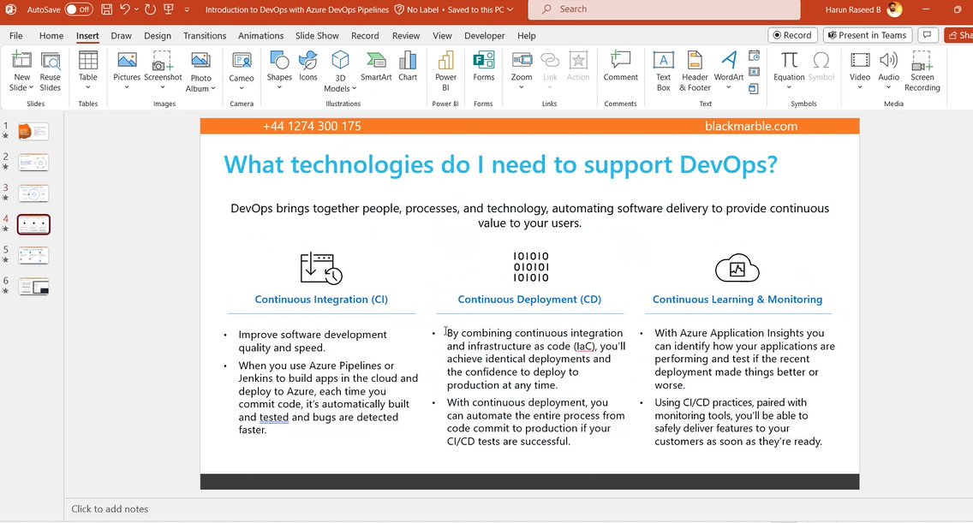

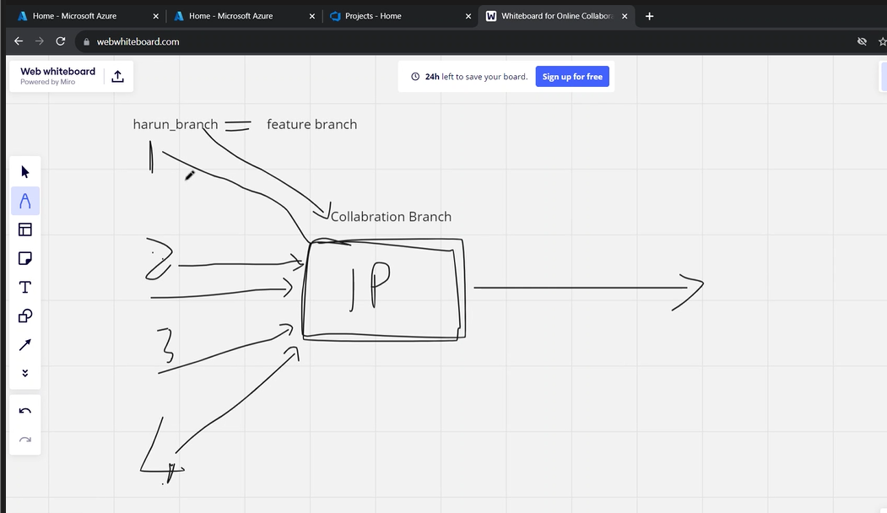

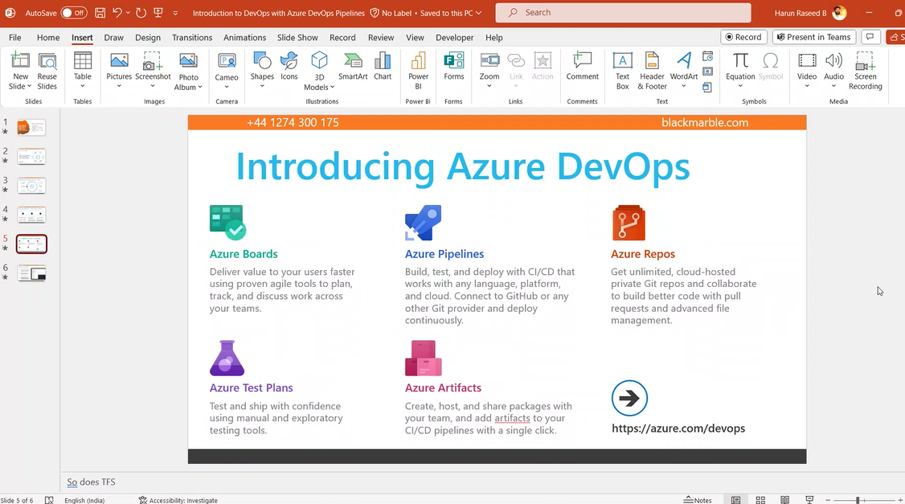

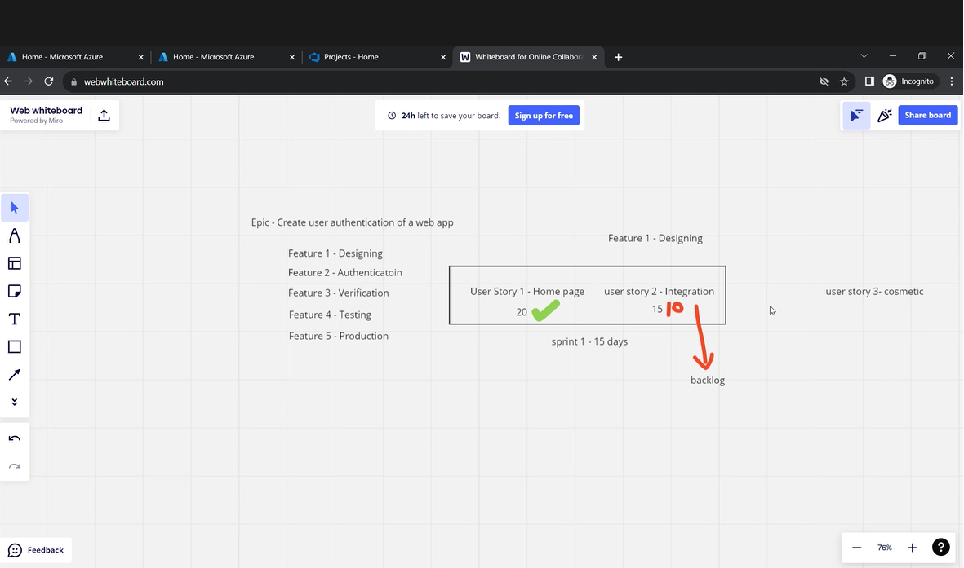

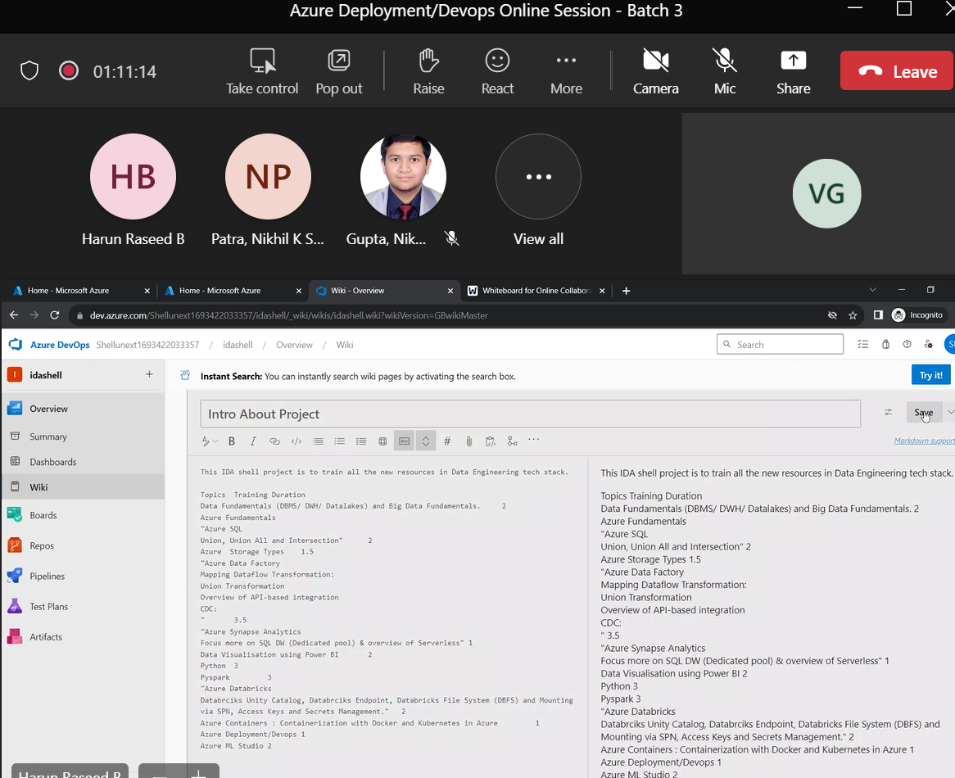

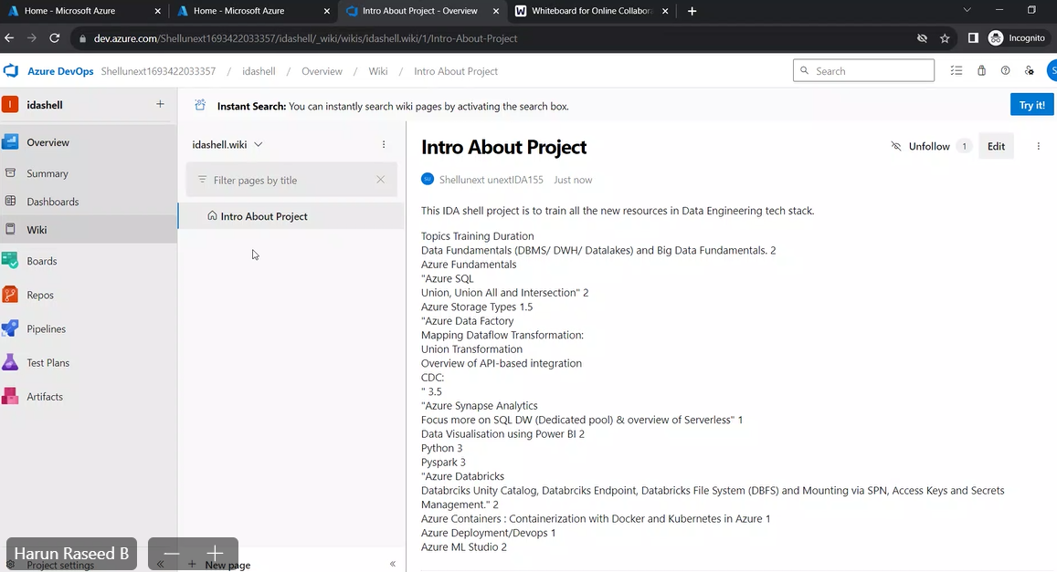

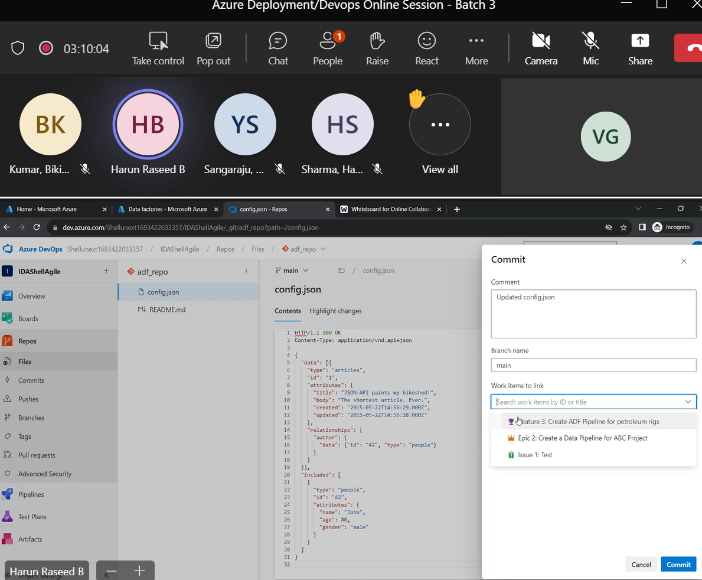

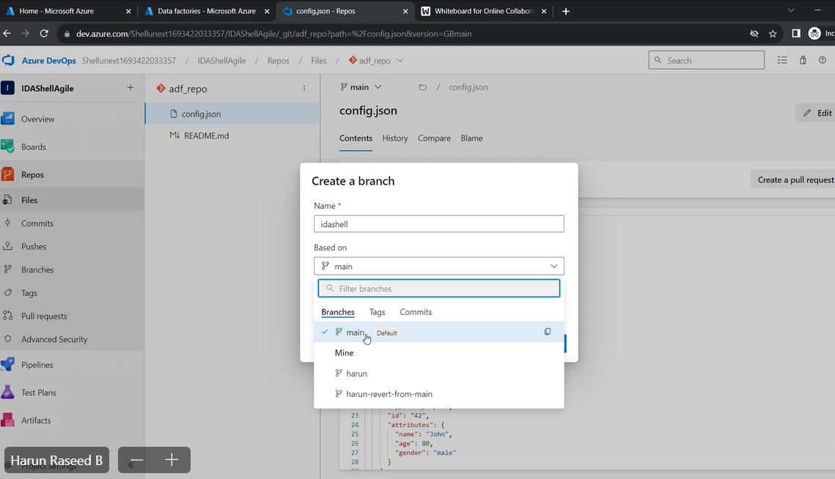

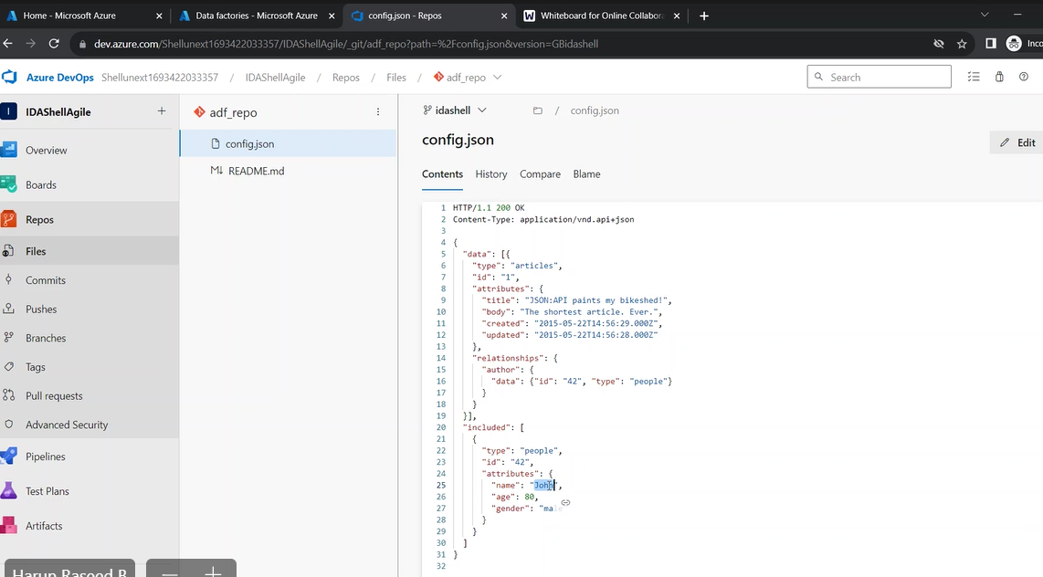

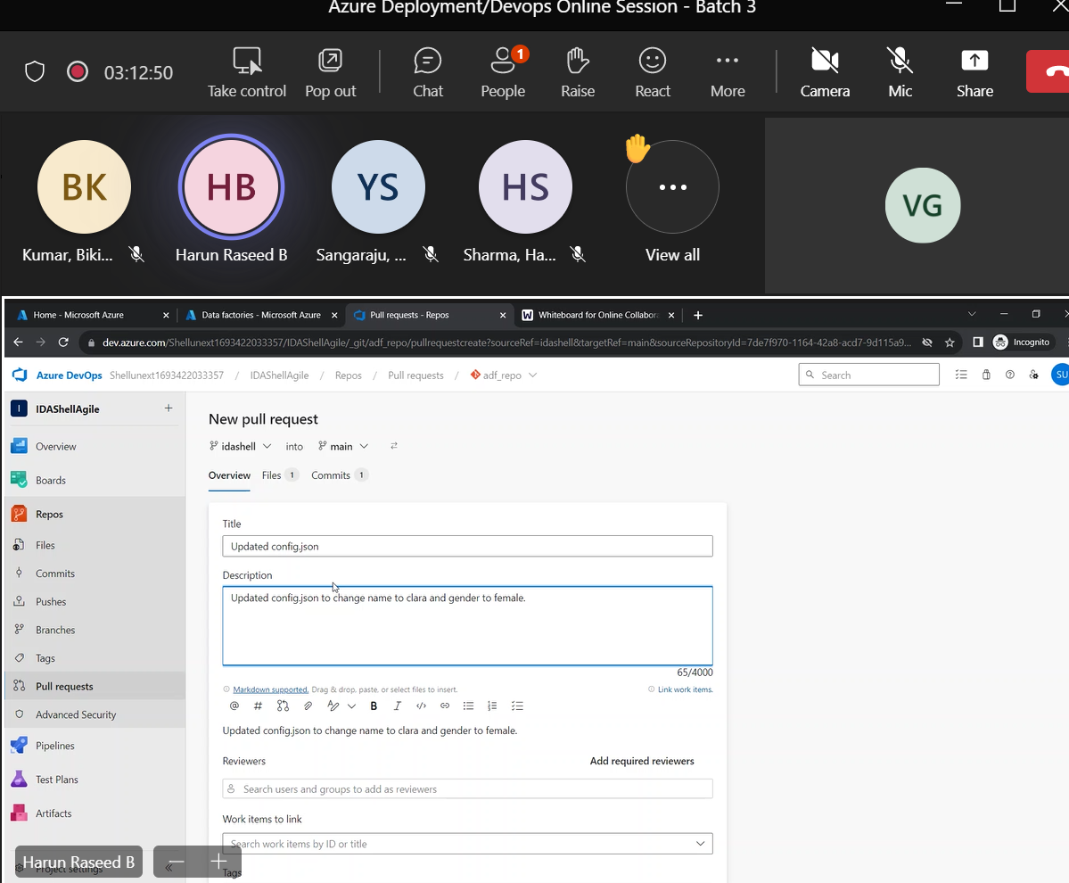

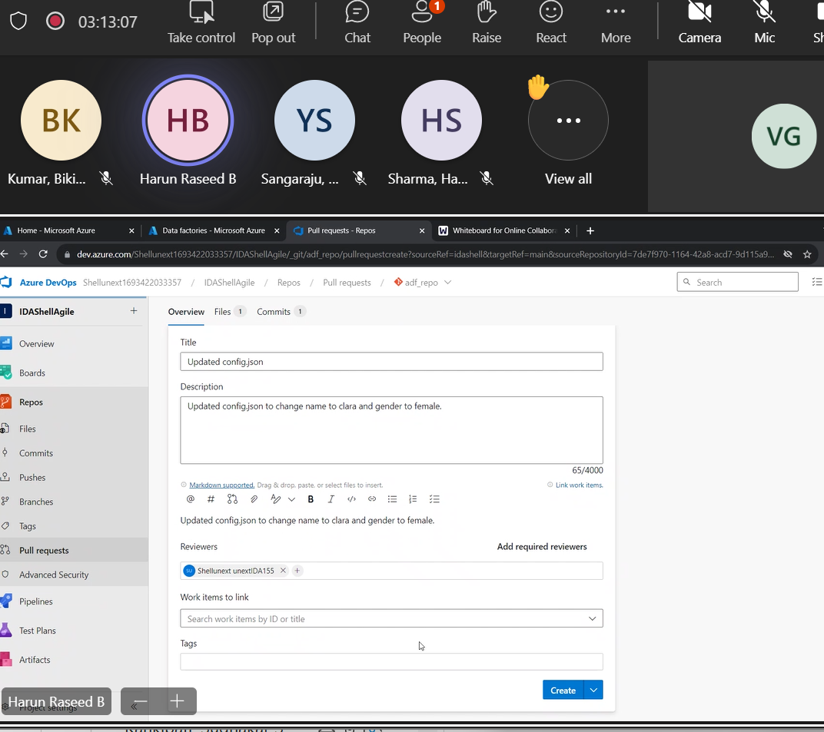

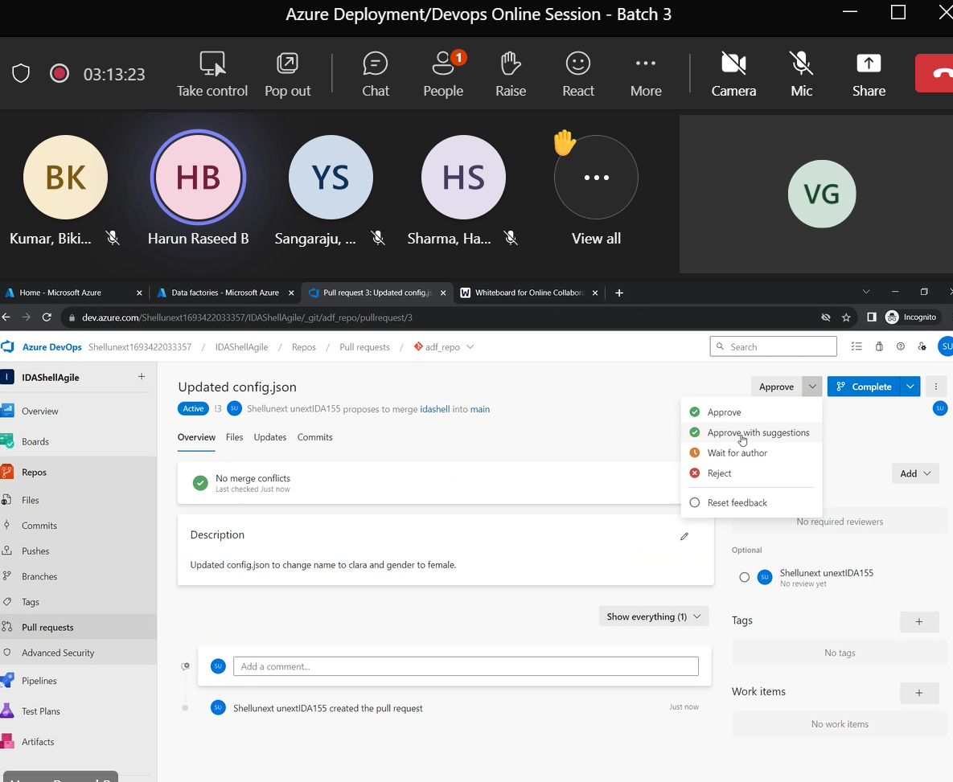

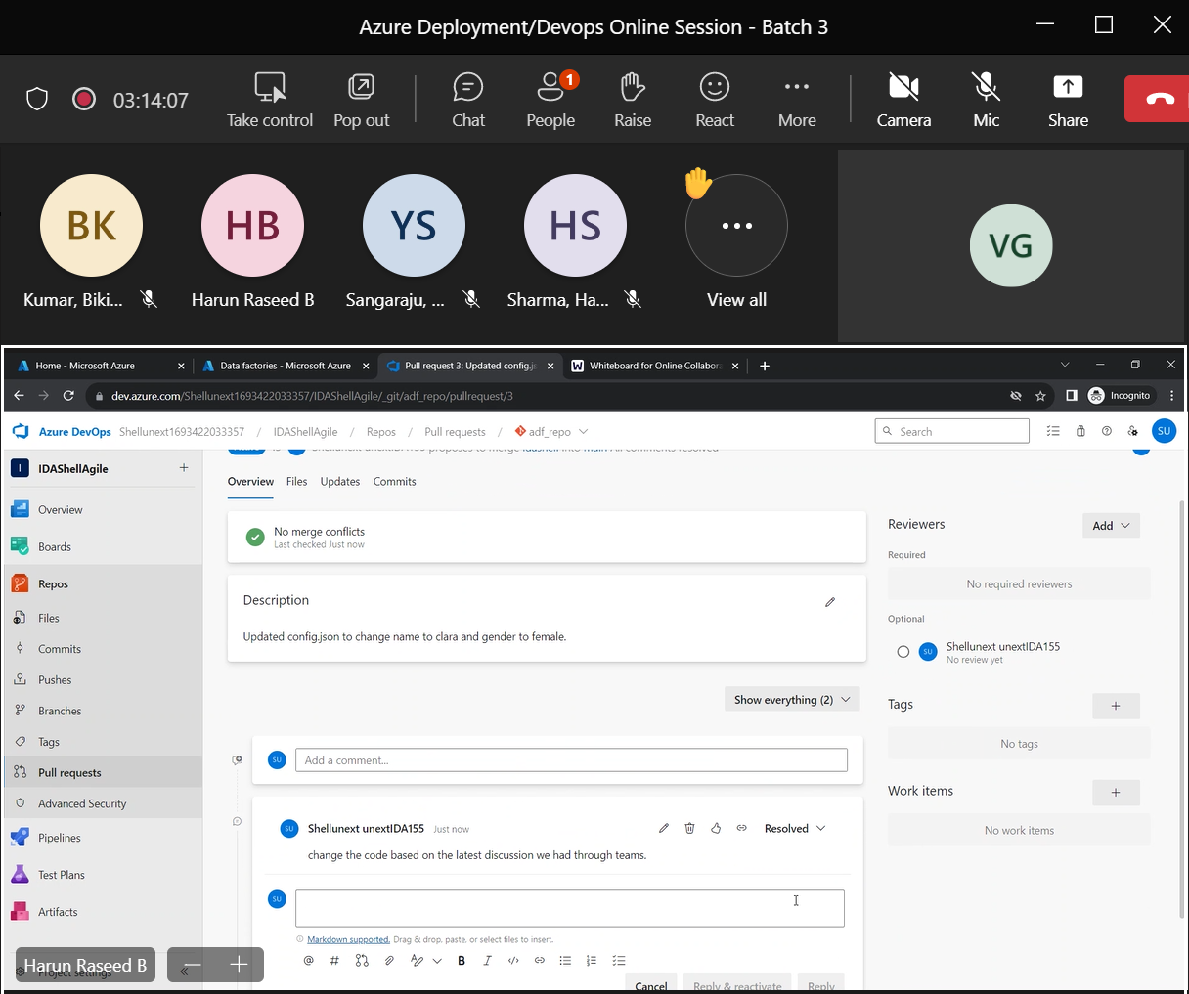

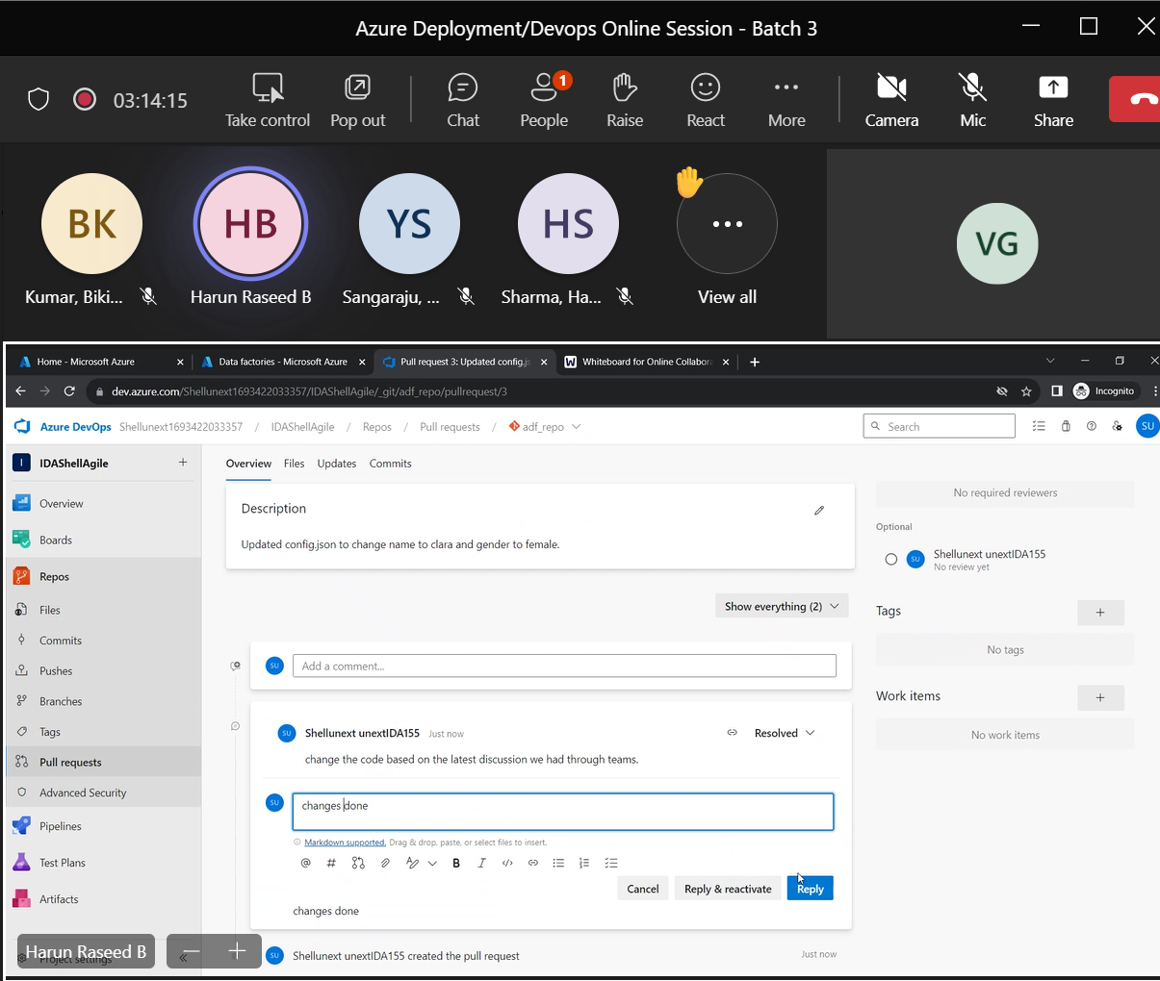

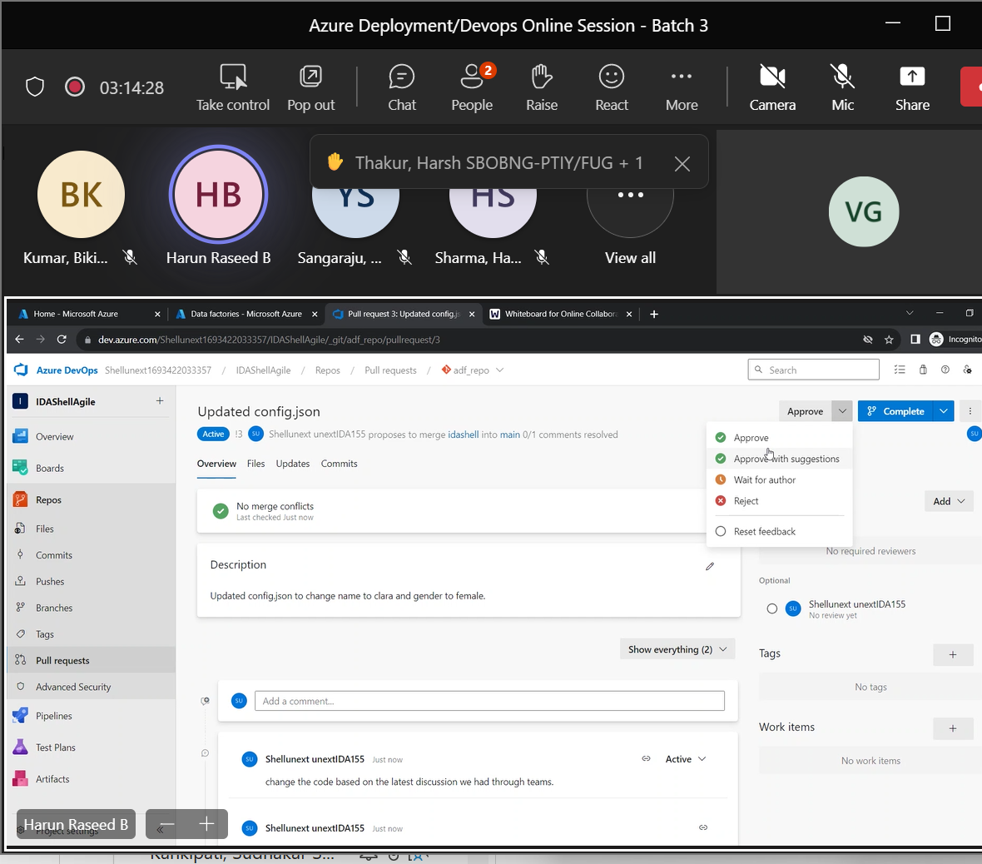

3/10/23

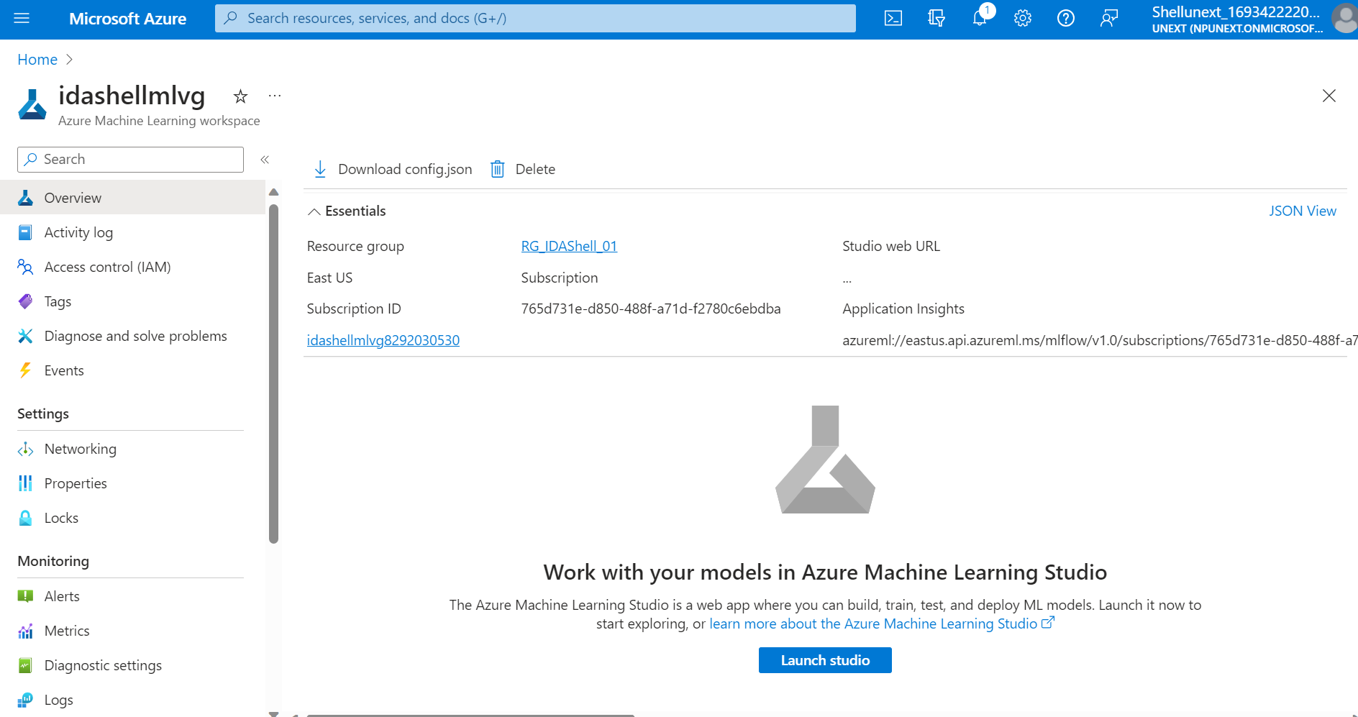

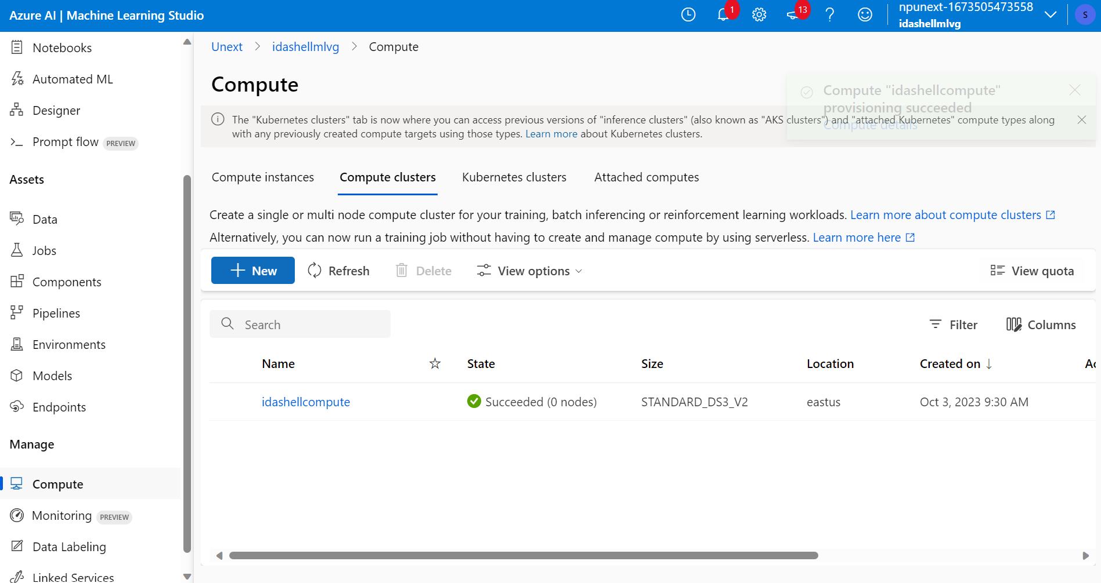

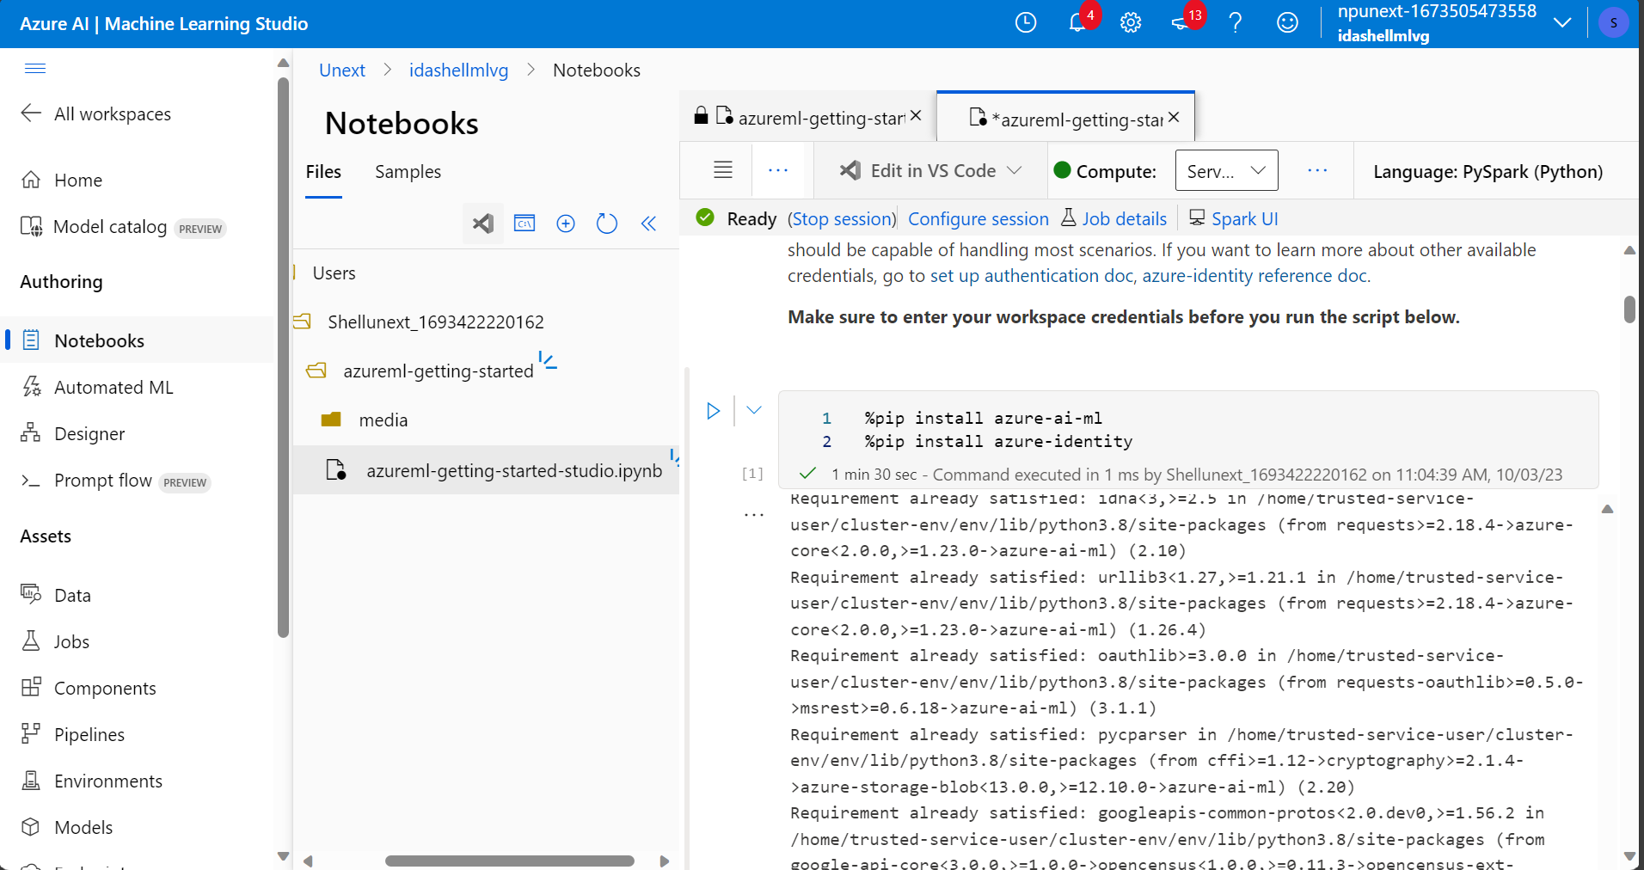

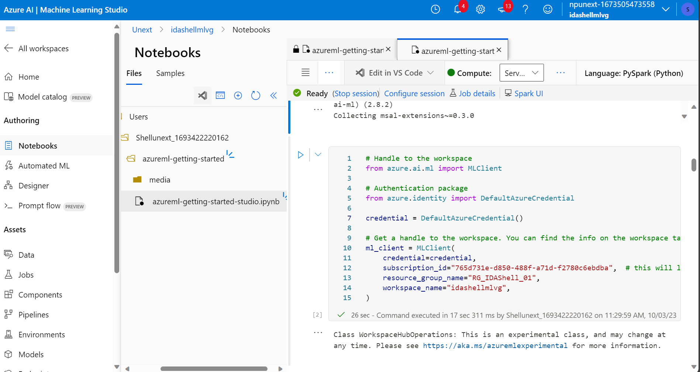



4/10/23

